St John's Science Snippets
Newsletter Issue 15 July 2023
Science at St John’s

What a busy year we have had! So many trips, clubs and enrichment opportunities. Year 6 visited the Linnaean Society in London, Reception visited the Aquarium, Year 1 went strawberry picking.
Healthy Environment Healthy me was once again very popular! In this club, children learn how to care for the environment and also themselves. Creating journey sticks and experiencing nature, being mindful in the moment, led to children leaving school calm and deciding for themselves to use this a strategy for self-regulation especially when they are anxious, stressed or angry. This is what a few children said:
“It made me feel peaceful and calm.”
“If I get stressed, I am going to make a journey stick at home because it makes me feel calm.”

We have shared another successful TEDS Day in which the whole school took part in activities to learn more about the importance of bees in nature. We even had friendly beekeeper, Cliff visit to share his knowledge. Reception made honey sandwiches and bee houses with their year 6 buddies. Other activities across the school included bee life cycles, surveys, maths with bee hotels, seed bomb making, research and poster creating to inform others about the importance of bees and how we can help to save them by making small changes to the way we garden.
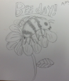

SOMETHING TO DO
Create your own journey stick whilst on a walk in the meadows, woods or park.
https://growingfamily.co.uk/craft/journey-stick-kids-nature-crafts/
FANCY A SURVEY TO HELP SCIENTISTS?
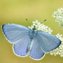
Why don’t you take part in the Great British Butterfly Count? https://bigbutterflycount.butterfly-conservation.org/
The Big Butterfly Count is a UK-wide survey aimed at helping us assess the health of our environment simply by counting the amount and type of butterflies (and some day-flying moths) we see.
The Big Butterfly Count begins on Friday 14th July 2023 and will run until Sunday 6th August.

What’s News?
The Eco-Committee have us up and running and we are on our way to being a PLASTIC CLEVER School.
On Monday 26th June, they led an assembly and they have completed a litter pick with alarming results.
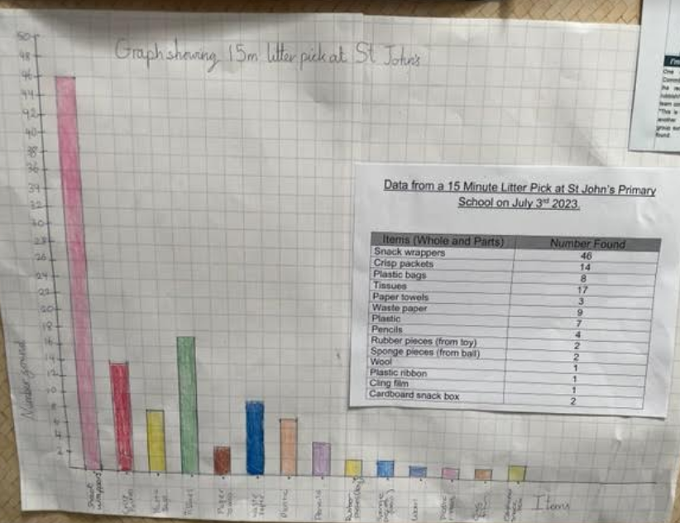
Next year, we are going to work hard to keep the school clean and tidy and do our bit to create a beautiful , clean environment.

SUMMER HOLIDAY FUN
- Take part in the BBC COUNTRYFILE WILD BRITAIN and log your acts of kindness in nature https://www.wild-britain.co.uk/. You can make bee baths, bug hotels, create wildlife ponds or feeding stations. What will you do to help nature in your garden?

- Go Wild with Wilder Holiday Club this spring & summer! Attend this Summer camp at Sevenoaks Wildlife Reserve and Jeffery Harrison Visitor Centre, Thursday 27 July 2023 - Friday 25 August 2023 9:00am - 4:00pm

- Plan a family visit to Wildwood https://kent.wildwoodtrust.org/your-visit/about-wildwood/
- A day trip to The Observatory Science Centre in Herstmonceaux, with over a 100 hands-on exhibits both inside and outdoors has something for everyone to try. They also have many workshops and is a great day out for all the family, especially if you love science. Look at the events listed here: https://www.the-observatory.org/events/august-2023

Make your own ice cream in a bag
Click on the link for instructions and a video tutorial
https://learning.sciencemuseumgroup.org.uk/wp-content/uploads/2019/02/SMG-Learning-Activities-Instant-Ice-Cream.pdf

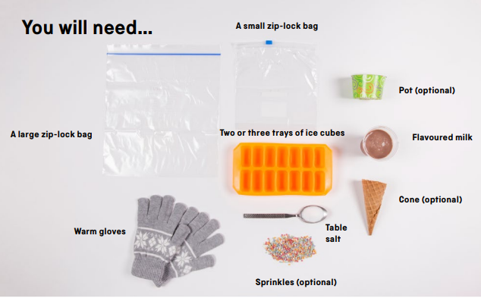

Answers
Mystery object is an apple stalk
Riddle : Fire

Guess the Mystery object
What could this zoomed in mystery object be?
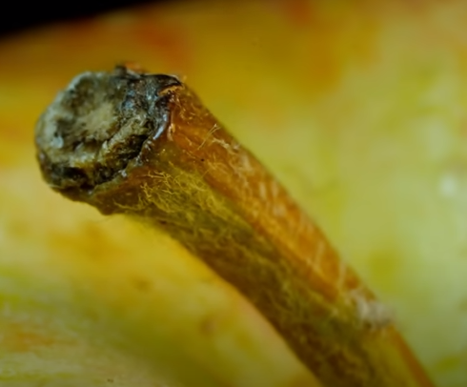
Answer above

I love to hear about the science you have been doing at home so come and talk to me about it.

If there is anything else you would like to see in the newsletter please do let me know.

Mrs Casewell

SUMMER SCIENCE RIDDLE

Give it food and it will live; give it water and it will die. What is it?

