St John's Science Snippets
Newsletter Issue 14 February 2023
SCIENCE CLUB NEWS
KS2 science club have had great fun using our new “Engineers Assemble” kit. We have explored wind power making wind turbines, tested different materials for parachutes as well as constructed lollipop stick catapults. We have become superb engineers able to problem solve, be resilient and work collaboratively. We have a chance to enter our designs into a competition too. Watch this space! 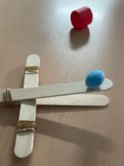

What’s News?
Reception and Year 1 had an exciting visit from Herstmonceaux Observatory today and journeyed through space in their inflatable astrodome.
How exciting! Do ask your child about their learning – they are space experts!
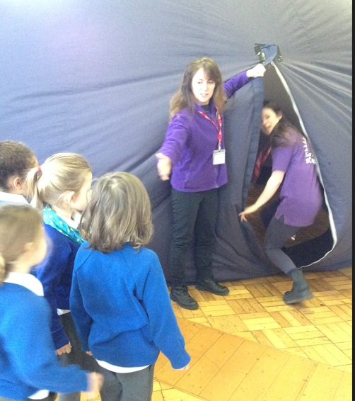
TRY AT HOME
MAKE A FLYING CUPID – STATIC ELECTRICITY
Making flying cupids is easy. You need:
- Tissue paper
- Markers
- Printable Cupid Template (available below for free)
- Scissors
- An inflated balloon
- Wool, flannel, or fleece fabric (A head of hair also works perfectly!)
- Draw a cupid on a piece of tissue paper.
- Cut out the tissue paper cupid and put it on a flat surface.
- Rub the balloon on fabric or hair for about 10 seconds.
- Hold the balloon a few inches over the tissue paper cupid and see what happens. If the balloon has a good static charge, the cupid should jump right up and stick to the balloon!
- Have fun making your cupid fly! 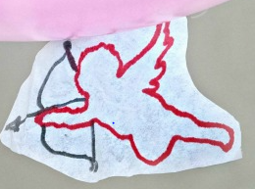

I love to hear about the science you have been doing at home so come and talk to me about it.

If there is anything else you would like to see in the newsletter please do let me know.

Mrs Casewell
COMING SOON!!!!
We will be kick starting British Science Week 10-19th March 2023 with a whole school STEM day. The theme this year is ‘Connections’. A fabulous theme to explore many areas of science, mathematics , engineering and technology. Look out for further information about the poster competition and other activities you can participate in at the start of the new term.

HALF TERM SCIENCE FUN
Biggin Hill Memorial Museum are hosting a range of workshops exploring flying machines - you can even make your own! Check link for details. https://bhmm.org.uk/event/february-half-term-at-biggin-hill-memorial-museum/

The Royal Institute are hosting a Family Fun Day

Saturday 15 February 11:00am – 4:00

https://www.rigb.org/half-term-science-fun-ri

