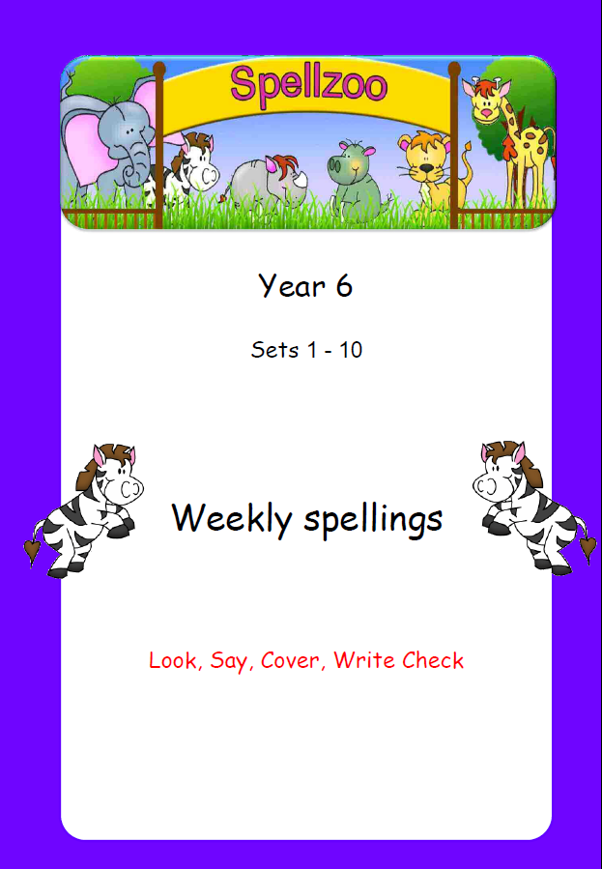

Set 1: Words ending in ‘cious’
 | 1st try | 2nd try
vice
vicious
space
spacious
malice
malicious
grace
gracious
suspect
suspicious
competition
definite
desperate

Set 2: Words ending in ‘tious’
 | 1st try | 2nd try
ambition
ambitious
caution
cautious
fiction
fictitious
infection
infectious
nutrition
nutritious
disastrous
especially
familiar

Set 3: Words ending in ‘cial’
 | 1st try | 2nd try
social
special
official
artificial
superficial
financial
commercial
beneficial
crucial
prejudicial
interfere
interrupt
language

Set 4: Words ending in ‘tial’
 | 1st try | 2nd try
initial
potential
essential
partial
confidential
residential
influential
impartial
palatial
torrential
leisure
lightning
marvellous

Set 5: Words ending in ant’ and ‘ance’
 | 1st try | 2nd try
infant
infancy
observant
observance
hesitant
hesitancy
important
importance
distant
distance
mischievous
muscle
necessary

Set 6: Words ending in ent’ and ‘ence’
 | 1st try | 2nd try
innocent
innocence
consequently
consequence
magnificent
magnificence
intelligent
intelligence
frequent(ly)
frequency
recommend
relevant
restaurant

Set 7 : Words ending in ance’ and ‘ence’
 | 1st try | 2nd try
assistant
assistance
resistant
resistance
attendant
attendance
different
difference
silent
silence
sincere
immediately
signature

Set 8: Words ending in ‘able’
 | 1st try | 2nd try
comfortable
enjoyable
valuable
breakable
agreeable
miserable
reliable
available
dependable
reasonable
soldier
stomach
sufficient

Set 9: Words ending in ‘ceable’/’geable’
 | 1st try | 2nd try
reinforceable
noticeable
pronounceable
replaceable
traceable
changeable
chargeable
enlargeable
knowledgeable
manageable
suggest
twelfth
variety

 Check
Look Say Cover Write
Set 10: Revision
 | 1st try | 2nd try
spacious
cautious
special
confidential
important
importance
consequently
consequence
different
difference
replaceable
knowledgeable
enjoyable
vegetable
vehicle
yacht
Y6T1

