EYFS and KS1 Maths Workshop for Parents and Carers
Set 1 Challenge



*****************************************
Try at home……


Resources for families at home:
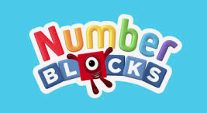
BBC iPlayer - Numberblocks (www.bbc.co.uk/iplayer/episodes/b08bzfnh/numberblocks) Episodes from the Numberblocks programme.
Learn how much fun counting can be with the Numberblocks - a fun-loving group of numbers who work together to solve problems big and small. We use this in school.
***************************

Numberblocks | Learning is fun with Learning Blocks | CBeebies shows (www.learningblocks.tv/numberblocks/home) Activities from Numberblocks including worksheets.
Welcome to Numberland! BAFTA award-winning Numberblocks helps children to see how numbers really work − and master a new key maths skill with every adventure. It’s a story of friends who can always count on each other − but, most of all, Numberblocks is about having fun with numbers.
***************************
Blog: Supporting the learning of mathematics at home | EEF (educationendowmentfoundation.org.uk) How to help your child at home. A 2 minute read – blog aimed to highlight some things you can do at home to support maths.
***************************

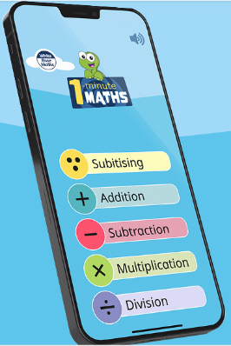
1 Minute Maths (app) We use White Rose Maths as our scheme of work in school alongside Mastering Number @KS1. This is a useful app that is in line with our teaching approaches.

What’s the app about? This first version of the app is aimed at Key Stage 1 pupils (ie, age 5-6 years). Individual one-minute tasks focus on adding and subtracting – and on ‘Subitising’, the skill of instantly recognising the number of items in a group without counting. Multiplication and division topics are also now available!


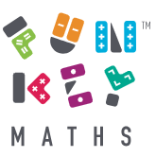
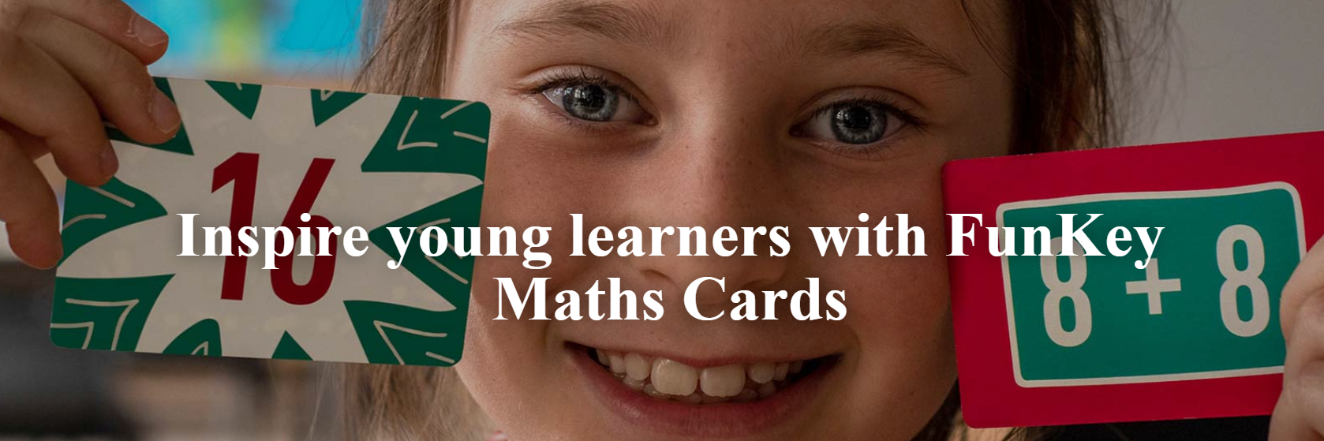
Order with us to get them cheaper –Usually £10.00 plus VAT but order through the school; we can get them for £8.50 as we can buy in bulk.

