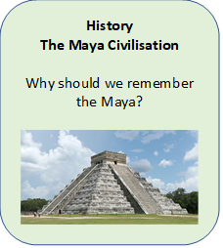

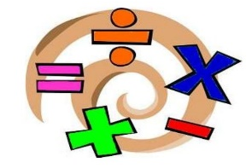
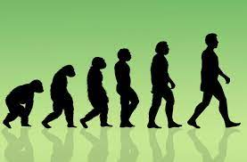

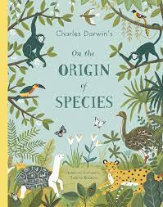
English
- The Graveyard Book – Ghost Story
- The Origin of Species – Non Chronological
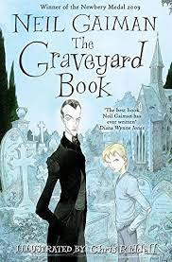
The Reading Circle

RE
Creation
Big question: How did we get here?

Term 1
Year 6

Art
Make my Voice Heard
We will explore how artworks can communicate messages and look at the drawing technique: chiaroscuro.
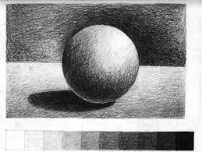

Visits/Visitors/trips
- Father Robin

Science
Evolution and Inheritance
- Explore the concept of evolution and investigate how various species vary and adapt to survive.
- Research the life and work of Charles Darwin.

Music
Swing music
Syncopation - its social and historical context
WW11


PE
- Hockey
- Netball
- Fitness
- 

Computing

Computing Systems and networks – communication

PSHE
Assertiveness
Cooperation
Safe/unsafe touches
Positive relationships


French
Greetings
Name
Age
Birthday
Alphabet


Maths
- Place Value
- Addition,
- Subtraction, Multiplication and Division

