English –
The Lost Homework
Nouns, verbs, adjectives and adverbs.

Developing empathy and exploring wider themes through a narrative.

Writing a letter to the wider community inviting them to share the experiences.

Term 1
Learning in Year 2

Visitors, trips and Special Events

- Black History Day
- Visit from Sevenoaks museum.


Practise keeping pulse by clapping or with rhythm sticks
Explore a range of musical instruments

PSHE

An introduction to Zones of Self-Regulation



Computing

- Computing systems and networks – IT around us.

Art
- Drawing – using charcoal and pencil to carry out lots of observational drawings

RE
- To know that Christians believe God created the universe.
- To retell the creation story from Genesis 1:1-2.3
- To think about what we can say thank you to God for


Science - Materials
- Explore and describe physical properties of everyday materials
- Comparing and grouping materials
- Perform simple tests to fund out how materials can change by squashing, bending, twisting and stretching

History
- Were schools different in the past?
- How have schools changed within living memory?
- How were schools different in the 1900s?
- How have schools changed?
- Would you have preferred to go to school in the past?
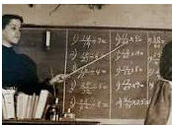
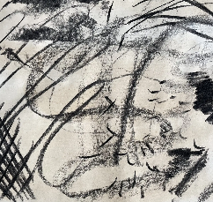

Maths - Place Value
- Recognising and partitioning numbers up to 100, grouping in 10s and recognising tens and ones.
- Writing numbers to 100 in expanded form.
- Estimating numbers on a number line.
- Counting in 2s, 5s and 10s.
- Counting in 3s.

Addition

Subtraction

Music

PE

- Fundamental Skills
- Team building

