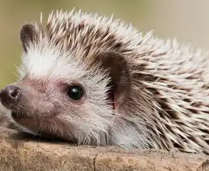
Welcome to Year 2 Hedgehogs
Reading
We ask that you read daily with your child. Each week in Year 2 we endeavour to set an e-book pitched at a personalised appropriate level for your child as well as a hand-held paper copy of a book pitched at a similar level. These will go out every Thursday. In Year 2, children tend to progress from e-books onto colour-banded books. When this happens, we will no longer send the Little Wandle e-books home, and instead you will receive just a hand-help paper copy of the appropriate colour-band for your child.
In addition, we will offer an opportunity for your child to borrow a ‘reading for pleasure’ book from our class book corner, which they can exchange daily if they so wish.
Finally, we will offer opportunities to borrow a school library book as regularly as possible. Please keep completed school library books in book bags until we are able to change them for a new one.
Homework
This year, the maths homework will be online through the website ‘MyMaths’. We will set weekly tasks every Thursday and ask that it is completed by the following Tuesday.
For English homework we ask that you read daily with your child. Please make a note in the reading diaries to let us know of any words your child struggled with in the e-books and likewise in the paperbacks. Please could you also make a note of which page your child has reached or if the book is finished and you are ready for a new one. Repeated reading is crucial to build fluency, pace and comprehension so we will be changing these books weekly, every Thursday.
As part of the English homework we also ask that you access the class page of the school website to view the Year 2 common exception words. Please practise these words across the year, a few at a time. Ideas and suggestions of how to approach learning these spellings are provided on the class page of the school website.

We look forward to working with year this year,

The Year 2 team.

