RE
How should we care for others and the world, and why does it matter?
- Retell bible stories and stories from another faith about caring for others and the world
- Talk about issues of good and bad
- Talk about how religions promote the golden rule
- Create some artwork about the golden rule

English –
‘The Dark’ by Lemony Snicket
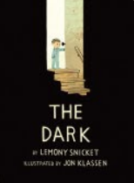
We will write: poetry, pieces of advice, explore different viewpoints in a debate, a call-and-response poem, retelling the story, instruction-writing and a non-chronological report.

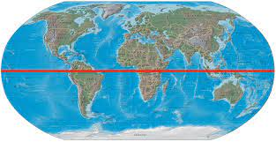
Geography
Would you prefer to live in a hot or cold place?
- Name and locate the 7 Continents of the world
- Locate the Equator, North and South Poles
- Describe hot and cold countries
- Talk about the differences and similarities between Nepal and the UK

D&T- Mechanisms
Make a Moving Monster
- Make pivots, levers and linkages
- Plan, design and make a moving monster

PE
- Yoga
- Wally Hall Girls teaching outdoor PE

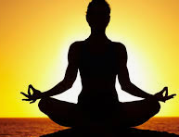
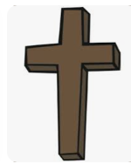
Science
Materials Part 2
- To be able to identify and compare the suitability of a variety of everyday materials.
- How bouncy is the material? What is the best material for blocking a hole in a bucket? Which tights are the stretchiest?
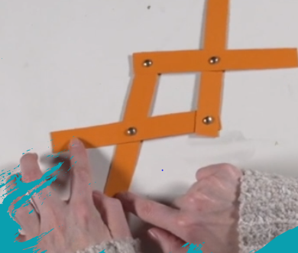
Computing
Creating media –

- digital photography

Visitors, trips and Special Events

- Nativity at the Ship Theatre
- Pantomime

PSHE
Valuing Difference
What makes us who we are?
How do we make others feel?


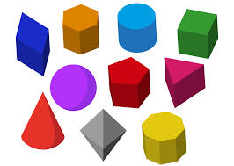
Maths -
- Addition
- Subtraction
Shape
- Recognise and sort 2D and 3D shapes
- Use lines of symmetry to complete shapes
- Count faces, edges and vertices on 3D shapes
- Make shape patterns

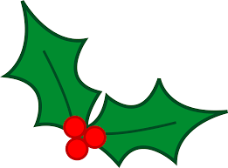
Music
- Christmas songs.
- Timbre, tempo, dynamics and graphic symbols.

Term 2
Learning in Year 2:
It’s Christmas Time!

