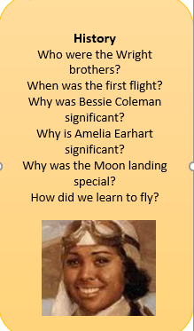
PSHE
- Keeping Safe

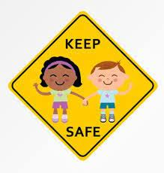

RE – Humanism
- Explain who Humanists are
- Describe what they believe makes us special
- Know the symbol for Humanism
- Understand that there are different ways to be happy
- Know the difference between reason and empathy
English
Narrative – rewriting this narrative with one innovation.

- ‘The Jolly Postman’ by y Janet and Allan Ahlberg
- Revision of the 4 word classes: nouns, adjectives, verbs and adverbs
- Revision of the 4 types of sentence: statements, exclamations, commands and questions
- Compound sentences using conjunctions

Term 3
Learning in Year 2

Science -
Animals including humans
- Animal offspring
- Life Cycles
- Growing up
- Survival: our basic needs
- Exercise
- Healthy living: food and hygiene.


Maths
- Shape – 2D and 3D
- Money - counting pounds and pence, finding change and two-step problems
- Multiplication- making equal groups and arrays
- Division - sharing and grouping
- 2x 5x 10x

Music:
- Duration
- Unison
- Round
- 20th Century Classical Music

PE
- Sending and receiving
- Gymnastics

Computing
- Creating media
- Making music

Visitors, trips and Special Events
St John’s Church

Art
- Painting and mixed media
- Life in colour
- Artist study – Romane Bearden



