Special Educational Needs and Disabilities (SEND) Information Report
St John’s C of E (Controlled) Primary School

Inclusion Team
SEND Governor:
Sonia Shah- Simmons
SENCO:
Donna Simpson
Contact: 01732 453944
office@stjohnssevenoaks.co.uk

Approved by: | FGB | Date: October 2024
Last reviewed on: | September 2024
Next review due by: | September 2025

Contents
1. What types of SEND does the school provide for? 4
2. Which staff will support my child? 5
3. What should I do if I think my child has SEND? 7
4. What happens if the school identifies a need? 8
5. How will the school measure my child’s progress? 9
6. How will I be involved in decisions made about my child’s education? 10
7. How will my child be involved in decisions made about their education? 11
8. How will the school adapt its teaching for my child? 12
9. How will the school evaluate whether the support in place is helping my child? 13
10. How will the school ensure my child has appropriate resources? 13
11. How will the school make sure my child is included in activities alongside pupils who don’t have SEND? 14
12. How does the school make sure the admissions process is fair for pupils with SEN or a disability? 15
13. How does the school support pupils with disabilities? 15
14. How will the school support my child’s mental health and emotional and social development? 16
15. What support is in place for looked-after and previously looked-after children with SEN? 16
16. What support will be available for my child as they transition between classes or settings or in preparing for adulthood? 17
17. What support is available for me and my family? (Local Offer) 18
18. What should I do if I have a complaint about my child’s SEND support? 19
19. Supporting Documents…………………………………………………………………………………………………………….19
20. Glossary 20

Dear parents and carers,
The aim of this Information Report is to explain how we implement our SEND policy. In other words, we want to show you how SEND support works in our school.
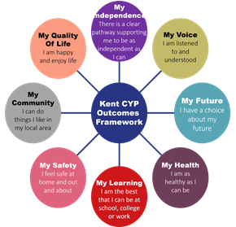
As educational professionals, we are all working towards the ultimate goal of growing independent young people as they prepare for adulthood. All provision and support we provide is working towards achieving the Kent Children and Young People (CYP) Outcomes Framework:

If you want to know more about our arrangements for SEND, read our SEND policy alongside this Information Report.
You can find our SEND policy on our website SEN-and-Disability-Policy-Jan-24.321970010.doc (live.com)
Note: If there are any terms we’ve used in this information report that you’re unsure of, you can look them up in the Glossary at the end of the report.

1. What types of SEND does the school provide for?

Our school provides for pupils with the following needs (as outlined in the SEND Code of Practice 2015):

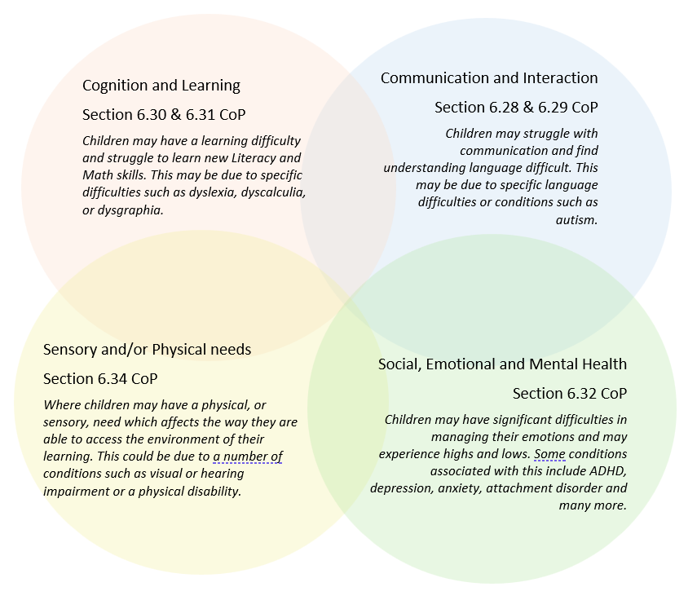

Often you will find that children’s needs overlap and are rarely confined to one area of need, which is why it is important to gain a wholistic overview of your child.
More information about the Areas of Need can be found in the Special educational needs and disability code of practice: 0 to 25 years (link below).
SEND_Code_of_Practice_January_2015.pdf (publishing.service.gov.uk)


2. Which staff will support my child, and what are their key responsibilities?

At St John’s, all staff are considered responsible for supporting the needs of pupils with SEND. Our staff are committed to regular, high-quality training to ensure that they have the knowledge and skills to better meet a wide range of pupil needs.
Below outlines key staff who may support your child.

Donna Simpson:
Donna has 30 years’ experience in the field of education and is our current SENCo (see below). In her role, she has attended a wide variety of training seminars that have covered the gamut of special educational needs. As well as supporting teaching staff and parents at St John’s, she also undertakes a number of interventions to support a wide range of learner needs which include emotional regulation, vocabulary acquisition and spelling.
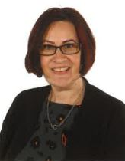
Alison Askin:
Alison has over 13 years of experience working in education; she began as a midday supervisor but quickly progressed to a teaching assistant role. Working in class, supporting children both one to one and in small groups, she undertook a wide-ranging number of interventions. Alison is now an advanced Drawing & Talking Practitioner as well as our SEMH/Family Support Assistant. Currently she delivers support that focuses on nurturing good mental health, emotional regulation, friendships and play skills.

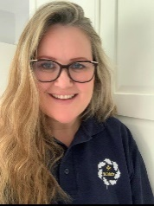
Melissa Hoemke:
Mel has been a Teaching Assistant for 4 years after successfully completing a Level 2 Certificate in Supporting Teaching and Learning. In her current role, she undertakes interventions to support students’ emotional and social development, including friendship groups, Lego-based therapy and Sensory Circuits. To further her knowledge and skills in supporting learner’s well-being, she is currently undertaking a NCFE CACHE Level 2 Certificate in Understanding Children and Young People's Mental Health

Katy Robinson
Katy qualified as a teacher with a particular focus on Key Stage 1 English. She has a variety of experience that has allowed her to develop an in-depth knowledge of phonics and reading acquisition. Katy has worked as a Teaching Assistant at St John’s since 2020, helping children to learn through targeted literacy interventions.

Our Special Educational Needs Co-ordinator, or SENCO
Our SENCO is Donna Simpson.
Mrs Simpson has four years’ experience in this role and has worked as both a teaching assistant and class teacher. She is a qualified teacher and holds a Master’s Degree in Teaching English to Speakers of other Languages.
Mrs Simpson achieved the National Award in Special Educational Needs Co-ordination in 2021.
Class/subject teachers
All of our teachers receive in-house SEN training, and are supported by the SENCO to meet the needs of pupils who have SEN.
Examples of such training include:
Adapting lessons to meet the needs of all learners.
Developing ‘Communication Friendly’ classrooms.
The use of assistive technology.
Dyslexia friendly classrooms.
The Zones of Regulation.
Circle of Friends.
Supporting children with demand avoidant profiles.
Autism Education Trust foundation training.

Teaching assistants (TAs)
We have a team of 12 TAs, including 2 higher-level teaching assistants (HLTAs) who are trained to deliver SEN provision.
We have a number of teaching assistants who are trained to deliver interventions such as Sensory Circuits, Attention Autism, Lego Therapy, Drawing and Talking Therapy, sand play and precision teaching techniques.
In the last academic year, TAs have been trained in maths support, attachment theory, demand avoidant profiles, sensory circuits, identifying mental health challenges and supporting autistic learners through the Autism Education Trust.
External agencies

Sometimes we need extra help to offer our pupils the support that they need. Whenever necessary we will work with external support services to meet the needs of our pupils with SEND and to support their families. These may include:


- Child and adolescent mental health services (CAMHS)
- Educational psychologists
- GPs or paediatricians
- NELFT practitioners
- Occupational therapists
- Therapeutic practitioners
- Safeguarding services
- School Liaison Officer
- School nurses
- SEND Inclusion Advisor
- Specialist Teacher Service
- Speech and language therapists
- Voluntary sector organisations

3. What should I do if I think my child has SEND?

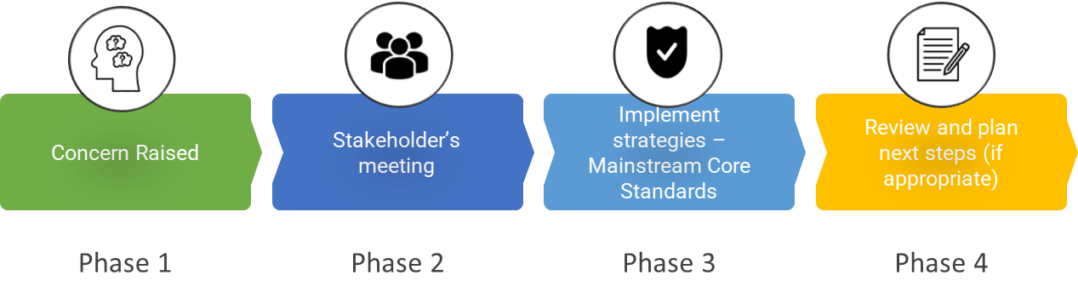

Phase 1 | If you think your child might have SEND, raise your concern with the school so that the SENCO is aware.  The first step is always to contact your child’s teacher to talk through your concerns with them.  A helpful document that explains our approach to identifying a special educational need can be found here: St John's Five Stages of Provision
Phase 2 | We will meet with you to discuss your concerns and try to get a better understanding of what your child’s strengths and difficulties are. Together we will decide what outcomes to seek for your child and agree on next steps. We will make a note of what’s been discussed and add this to your child’s record.
Phase 3 | We will implement the agreed strategies and monitor these over an agreed period of time. These are likely to be universal strategies set out in the mainstream core standards. A copy of this can be found here: https://www.kelsi.org.uk/__data/assets/pdf_file/0005/117257/Special-educational-needs-mainstream-core-standards-guide-for-parents.pdf . This will initiate the ‘Graduated Approach’ where support will be continually reviewed. See next page for more details.
Phase 4 | If we decide that your child needs SEND support, we will formally notify you and your child will be added to the school’s SEND register. They will receive additional support and this will be reviewed using the assess, plan, do, review model.  A helpful summery of this process at our school can be found here: St. John's SEND Pathway.docx - Google Docs

4. What happens if the school identifies a need?
The same process is followed if a concern is raised by the school.

All our class teachers are responsible for the monitoring of all pupils who have been identified as having SEND. They also review those who are not making the expected level of progress in their schoolwork or socially. This might include assessment of reading, writing or maths work, social relationships or general wellbeing. Pupil Progress Meetings are also held three times a year, with the Senior Leadership Team (SLT) to identify those learners who may not be making the expected levels of progress. Regular book scrutinies and lesson observations are carried out by SLT to ensure that the needs of all children are met and that the quality of teaching and learning is high.
If the teacher notices that a pupil is having difficulties, they try to find out if the pupil has any gaps in their learning. If they can find a gap, the school will provide appropriate support. Pupils who don’t have SEND usually make progress quickly once the gap in their learning has been filled.
If the pupil is still finding it difficult to make the expected progress, the teacher will talk to the SENCO, and will contact you to discuss the possibility that your child has SEND, and the school will follow the graduated approach (see previous page).

5. How will the school measure my child’s progress?

We will follow the ‘graduated approach’ to meeting your child’s SEND needs.
The graduated approach is a 4-part cycle of assess, plan, do, review.
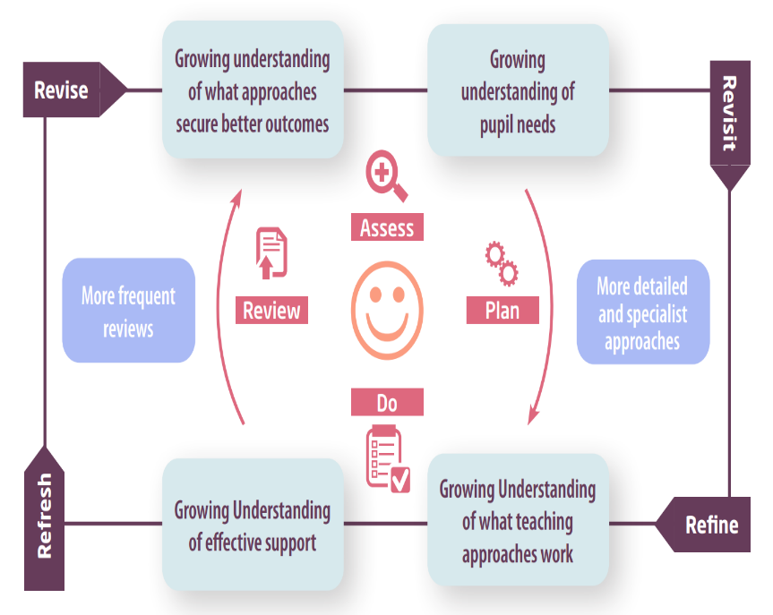

Assess | If your child is not making the expected level of progress, we will make an assessment to find out what strengths and difficulties your child has. We will ask for you and your child’s input, as well as getting help from external professionals where necessary.
Plan | In discussion with you and your child, we will decide what outcomes we are hoping to achieve. We will make a plan of the support we will offer your child to help them meet those outcomes. We will make a record of this and share it with you and all relevant school staff.
Do | We will put our plan into practice.  The class teacher, with the support of the SENCO, will be responsible for working with your child on a daily basis, and making sure the support we put in place is having the impact we intended.
Review | We will assess how well the support we put in place helped the pupil to meet the outcomes we set. We will use our improved understanding of your child’s needs to improve the support we offer; this may mean the Plan, Assess, Do, Review cycle continues.

6. How will I be involved in decisions made about my child’s education?
We will provide regular reports on your child's progress; if they are part of our SEN Register then their Personal Learning Plans are reviewed three times a year. They will also receive an annual report in the summer term.
A member of staff who knows your child well will meet you at least 3 times a year to:
- Set clear outcomes for your child’s progress
- Review progress towards those outcomes
- Discuss the support we will put in place to help your child make that progress
- Identify what we will do, what we will ask you to do, and what we will ask your child to do
The SENCO may also attend these meetings to provide extra support.
We know that you’re the expert when it comes to your child’s needs and aspirations. So, we want to make sure you have a full understanding of how we’re trying to meet your child’s needs, so that you can provide insight into what you think would work best for your child.
We also want to hear from you as much as possible so that we can build a better picture of how the SEND support we are providing is impacting your child outside of school.
If your child’s needs or aspirations change at any time, please let us know right away so we can keep our provision as relevant as possible.
If you have concerns that arise between these meetings, please contact the school office office@stjohnssevenoaks.co.uk to arrange a meeting with your child’s teacher.

7. How will my child be involved in decisions made about their education?

The level of involvement will depend on your child’s age and individual needs. We recognise that no two pupils are the same, so we will decide on a case-by-case basis, with your input.
We may seek your child’s views by asking them to:
- Attend meetings to discuss their progress and outcomes
- Prepare a presentation, written statement, video, drawing, etc.
- Discuss their views with a member of staff who can act as a representative during the meeting
- Complete a survey


8. How will the school adapt its teaching for my child?
At St John’s our environment is adapted to the needs of pupils as required. For those with physical needs, this includes:
- Ramps
- Suitable corridor widths
- Disabled parking bay
- Disabled toilets and changing facilities
- Library shelves at wheelchair-accessible height
More information about our Accessibility Plan can be found here: download.asp (stjohnssevenoaks.co.uk)
Your child’s teacher is responsible and accountable for the progress and development of all the pupils in their class.
High-quality teaching is our first step in responding to your child’s needs. We will make sure that your child has access to a broad and balanced curriculum in every year they are at our school.
We will adapt our approaches to how we teach to suit the way the pupil works best. There is no 'one size fits all’ approach to adapting the curriculum, we work on a case-by case basis to make sure the adaptations we make are meaningful to your child and are guided by the Mainstream Core Standards in the first instance.

These adaptations may include:
- Adapting our approaches, for example, giving longer processing times, pre-teaching of key vocabulary, reading instructions aloud, etc.

- Adapting our lessons, resources and staffing appropriately.

- Using recommended aids, such as i-pads, laptops, coloured overlays, visual timetables, larger font, etc.

- Teaching assistants or support staff will support pupils appropriately depending on their presentation of need

- Scaffolding lesson materials

- Allowing children to present their learning in different ways e.g. building models or giving verbal answers as opposed to writing them.
- Ensuring curriculum plans consider “the golden thread” of SEN and are planned and implemented with the needs of all learners in mind.

We may also provide the following interventions:
Precision teaching for phonics, reading and spelling
1:1 and small group support for phonics with a specialist teaching assistant
Repeated Reading
The Harberton Reading Programme
Morph Mastery for spelling
Handwriting
Support to develop fine motor control
Dyscalculia Solution
Small group maths support with a specialist tutor
Drawing and Talking Therapy
Sand play Therapy
Lego Therapy
Attention Autism
Sensory Circuits
Friendship Circle
Zones of Regulation/Emotional Regulation Support
Sessions with a councillor (when available)

These interventions are part of our contribution to Kent County Council’s local offer.

9. How will the school evaluate whether the support in place is helping my child?

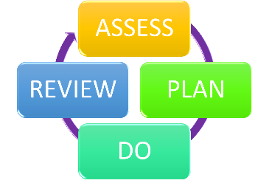
We will evaluate the effectiveness of provision for your child by:
- Reviewing their progress towards their goals each term
- Reviewing the impact of interventions after approximately 10 weeks
- Using pupil questionnaires
- Monitoring by the SENCO
- Using provision maps to measure progress
- Holding an annual review (if they have an education, health and care (EHC) plan)

10. How will the school ensure my child has appropriate resources?

As part of our budget we receive ‘notional SEN funding’. This funding is used to ensure that the quality of teaching is good in the school and that there are sufficient resources to deploy additional and different teaching for pupils requiring SEN support. We can spend up to £6,000 per year of resource to meet the needs of each pupil. If a child requires spending in excess of this amount, we are able to apply to the Local Authority for High Needs Funding. This is available only for pupils who need significant support, usually linked to a diagnosis and/or intervention from external agencies. This is available for pupils with or without an Education and Health Care plan.
It may be that your child’s needs mean we need to provide additional resources such as:
- Additional resources to support their learning
- Adaptations to in class support
- Further training for our staff
- External specialist expertise
Where appropriate, we will consult with external agencies to get recommendations on what will best help your child access their learning and use our best endeavours to ensure these are supplied.

11. How will the school make sure my child is included in activities alongside pupils who don’t have SEND?


The expectation is that all schools provide an inclusive provision for all pupils. It may be necessary for some pupils to receive interventions in addition to a broad and balanced curriculum.
All of our extra-curricular activities and school visits are available to all our pupils, including our before and after-school clubs.
All pupils are encouraged to go on our school trips, including our residential trip(s) which children attend in Year 4 (1 night), Year 5 (2nights) and Year 6 (3/4 nights).
All pupils are encouraged to take part in all aspects of school life, this includes (but is not limited to) sports days, educational visits, school performances and special workshops.
No pupil is ever excluded from taking part in these activities because of their SEN or disability and we will make whatever reasonable adjustments are needed to make sure that they can be included.

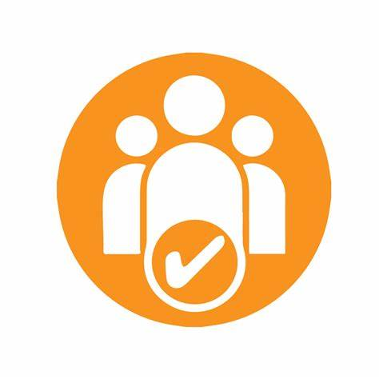
12. How does the school make sure the admissions process is fair for pupils with SEN or a disability?

At St John’s, we welcome all children, the phrase from our vision ‘All Different, All equal, all learning together in God’s world’ underpins our approach to supporting any pupils who wish to attend St John’s.
Anyone who applies to our school will be offered a tour of the school where they meet with the Head teacher and SENCO in cases where children have SEND. This gives parents an opportunity to discuss and share any SEND information with us and us to see what adjustments or resources may be needed to support the child. If the child accepts the place at St John’s efforts are made to contact nurseries or other schools to get up to date information about any support the child was receiving so that we can prepare and have things in place for when the child starts. We would then hold a meeting with parents/carers after the child has started to see how they have settled and make any required adjustments.
As a Voluntary controlled school, we follow Kent’s admission criteria when admitting children. Those with an EHCP, we would need to ensure we have the resources to be able to meet the need of the child before admitting so would request seeing any paperwork or meet with parents to discuss need before admitting.

13. How does the school support pupils with disabilities?


Our school site is fully accessible. We are on one level and there are ramps to get outside where needed. We would be able to add in handrails around the school if required. Any other individual requirements would be discussed and put in place as necessary.

You’re disabled under the Equality Act 2010 if you have a physical or mental impairment that has a ‘substantial’ and ‘long-term’ negative effect on your ability to do normal daily activities.

14. How will the school support my child’s mental health and emotional and social development?
At St John’s we understand that an important feature of the school is to enable all pupils to develop emotional resilience and social skills, both through direct teaching, for instance Personal, Social, Health and Economic (PSHE), or circle time in class and indirectly with every conversation adults have with pupils throughout the day. Over the last few years we have embedded the concept of ‘I messaging’ which helps children to express their feelings clearly and calmly to each other. We also use the Zones of Regulation across the school which helps children to identify and manage their own emotions.
For some pupils, with the most need for help in this area, more targeted support can be put in place. This may include interventions such as play therapy, Lego therapy, social skills groups, sensory circuits/play or mentoring by identified members of staff. Sometimes this may involve using resources such as the ‘Incredible Five-Point Scale’, personalised Zones of Regulation, social stories or comic strip conversations or the use of diaries or mood thermometers to track anxiety (at home and at school). We may also be able to refer pupils for external support or counselling through the Early Intervention Service or to CAHMs for specialist mental health support.
Pupils in the early stages of emotional and social development, because of their special educational needs, will be supported to enable them to develop and mature appropriately. This will usually require additional and different resources, beyond that required by pupils who do not need this support. It may also require personalised adaptations to the class and school environment or to the school behaviour policy in order to take into consideration those needs, especially where the behaviour is linked to a diagnosed condition such as ASC, ADHD or attachment issues. This may include task and reward provision, sensitive seating, fiddle toys or ear defenders, personal reward charts to promote good social skills or learning behaviour.
We also have a “zero tolerance” approach to bullying. We prevent bullying in the school by the application of a robust anti bullying policy which can be found here: download.asp (stjohnssevenoaks.co.uk)

15. What support is in place for looked-after and previously looked-after children with SEND?


Donna Simpson, our SENCO, will make sure that all teachers understand how a looked-after or previously looked-after pupil’s circumstances and their SEND might interact, and what the implications are for teaching and learning.
Pupils who are looked-after or previously looked-after will be supported much in the same way as any other child who has SEND. However, looked-after pupils will also have a personal education plan (PEP). We will make sure that the PEP and any SEND support plans or EHC plans are consistent and complement one another.

16. What support will be available for my child as they transition between classes or settings or in preparing for adulthood?
Between years

To help pupils with SEND be prepared for a new school year we:
- Ask both the current teacher and the next year’s teacher to attend a final meeting of the year when the pupil’s SEND is discussed
- Schedule lessons with the incoming teacher towards the end of the summer term
- Allocate a personal transition booklet for pupils to share at home over the summer holidays
- Invite them to visit their classroom and meet their new class teacher the day before term starts.
Between schools
When your child is moving on from our school, we will ask you and your child what information you want us to share with the new setting.

Between phases (for primary schools)
The SENCO of the secondary school will have a meeting with our SENCO. They will discuss the needs of all the pupils who are receiving SEND support.
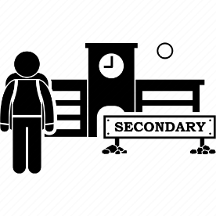
Pupils will be prepared for the transition by:
- Learning how to get organised independently
- Plugging any gaps in knowledge
- Planning how they might handle challenging situations
- Attending extra transition days (where available)

17. What support is available for me and my family?
If you have questions about SEND, or are struggling to cope, please get in touch to let us know. We want to support you, your child and your family.
To see what support is available to you locally, please refer to the padlet provided on our website, it has a number of links on a wide range of topics. A link to the resource can be found here: https://padlet.com/dsimpson90/dfrckgihegqfqzub

Kent County Council publishes information about the local offer on their website: Special educational needs and disabilities (SEND) - Kent County Council
The special educational needs and disabilities information advice and support services (SENDIASS) link is: SENDIASS Home - Kids

Local charities that offer information and support to families of pupils with SEND are:
Kent Pact: Home - Kent PACT (kentpactnew2022.co.uk)
Information Advice and Support Kent: Home | IASK
BEAMS: We Are Beams | Supporting Disabled Children and Young People
Mind, West Kent: ASD support - West Kent Mind

National charities that offer information and support to families of pupils with SEND are:
- IPSEA
- SEND family support
- NSPCC
- Family Action
- Special Needs Jungle

18. What should I do if I have a complaint about my child’s SEND support?
Complaints about SEND provision in our school should be made as soon as possible with the relevant member of staff or the Headteacher as appropriate, either in person or by letter, telephone, or email. A link to our school’s complaints policy can be found here: Complaints-June-2023.300880517.doc (live.com)
If you are not satisfied with the school’s response, you can escalate the complaint. In some circumstances, this right also applies to the pupil themselves.
To see a full explanation of suitable avenues for complaint, see pages 246 and 247 of the SEND Code of Practice.
If you feel that our school discriminated against your child because of their SEND, you have the right to make a discrimination claim to the first-tier SEND tribunal. To find out how to make such a claim, you should visit: https://www.gov.uk/complain-about-school/disability-discrimination
You can make a claim about alleged discrimination regarding:
- Admission
- Exclusion
- Provision of education and associated services
- Making reasonable adjustments, including the provision of auxiliary aids and services
Before going to a SEND tribunal, you can go through processes called disagreement resolution or mediation, where you try to resolve your disagreement before it reaches the tribunal. The resolution and mediation service used by Kent County Council is currently Global Mediation: Special Educational Needs and Disability - Global Mediation

19. Supporting documents

- Equality Information and Objectives Policy
- Child protection and safeguarding policy
- Behaviour Policy
- Accessibility Plan
- Attendance and punctuality policy
- SEND policy
- SEN & Disabilities Code Of Practice 2015
- Mainstream Core Standards

20. Glossary
- Access arrangements – special arrangements to allow pupils with SEND to access assessments or exams
- Annual review – an annual meeting to review the provision in a pupil’s EHC plan
- Area of need – the 4 areas of need describe different types of needs a pupil with SEND can have. The 4 areas are communication and interaction; cognition and learning; physical and/or sensory; and social, emotional and mental health needs.
- CAMHS – child and adolescent mental health services
- Differentiation – when teachers adapt how they teach in response to a pupil’s needs
- EHC needs assessment – the needs assessment is the first step on the way to securing an EHC plan. The local authority will do an assessment to decide whether a child needs an EHC plan.
- EHC plan – an education, health and care plan is a legally-binding document that sets out a child’s needs and the provision that will be put in place to meet their needs.
- First-tier tribunal/SEND tribunal – a court where you can appeal against the local authority’s decisions about EHC needs assessments or plans and against discrimination by a school or local authority due to SEND
- Graduated approach – an approach to providing SEND support in which the school provides support in successive cycles of assessing the pupil’s needs, planning the provision, implementing the plan, and reviewing the impact of the action on the pupil
- Intervention – a short-term, targeted approach to teaching a pupil with a specific outcome in mind
- Local offer – information provided by the local authority which explains what services and support are on offer for pupils with SEND in the local area
- Outcome – target for improvement for pupils with SEND. These targets don't necessarily have to be related to academic attainment
- Reasonable adjustments – changes that the school must make to remove or reduce any disadvantages caused by a child’s disability
- SENCO – the special educational needs co-ordinator
- SEN – special educational needs
- SEND – special educational needs and disabilities
- SEND Code of Practice – the statutory guidance that schools must follow to support pupils with SEND
- SEND information report – a report that schools must publish on their website, that explains how the school supports pupils with SEND
- SEND support – special educational provision which meets the needs of pupils with SEND
- Transition – when a pupil moves between years, phases, schools or institutions or life stages

