

St John’s C of E Primary School: Nurture Provision.
Information for Parents

Introduction
Nurture is vital in shaping a child’s social, emotional and behavioural development. A child’s early experience of being nurtured and developing an attachment, with a caring adult, affects all aspects of their future behaviour and development. There is evidence that children’s learning is most effective when they have a sense of emotional well-being and positive self-esteem. Our Nurture Groups aim to give children the opportunity to re-visit early learning skills, along with promoting and supporting their social and emotional development. There is great emphasis on emotional literacy, language development and communication. Pupils are immersed in an accepting and warm environment that helps pupils develop positive relationships with both teachers and peers.

The Six Principles of Nurture.
Nurture UK describes the six principles of nurture as:
1.Children's Learning is Understood Developmentally
We are all individuals. We learn in our own way and in our own time.

2. The Classroom offers a Safe Base
A classroom or school should be a safe place where everyone feels happy and valued.

3. Nurture is Important for the Development of Self-Esteem
Looking after ourselves and other people makes us feel good in mind and body.

4. Language is Understood as a Vital Means of Communication
Using words to talk about how we feel is important.

5. All Behaviour is Communication
It’s not always easy to express how we feel in words. The way we behave towards other people says a lot about how we are feeling.

6. Transitions are Significant in the Lives of Pupils
Change happens all the time. It can be exciting but it can also be scary.

Nurture Groups at St John’s
Class teachers, our SENCo (Mrs Simpson) and Mrs Askin (our Social, Emotional and Mental Health Support staff) liaise to identify children who would benefit from access to Nurture sessions.
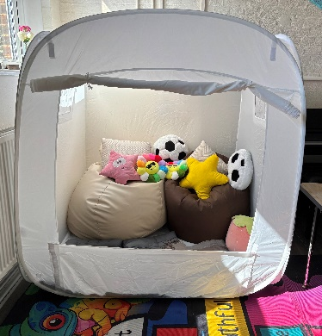
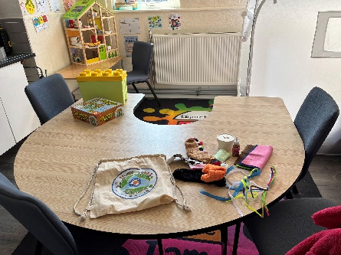
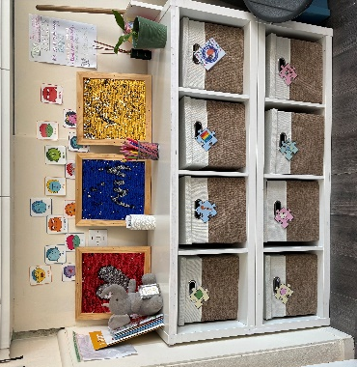
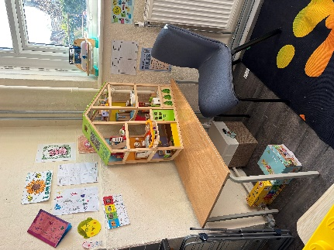
Sessions are run by Mrs Askin in our dedicated nurture space, The Acorn Room.


Groups offer a short term, focused intervention that addresses barriers to learning arising from social, emotional or behavioural difficulties, in an inclusive, supportive manner. The intervention lasts for six to twelve weeks and sessions last for 30 to 40 minutes depending on their purpose and number of children. Sessions comprise a variety of activities, which include structured input, using our social and emotional learning intervention programmes from Hamish and Milo (https://hamishandmilo.org/ ), free play, snack time and reflection.
A Typical Session in the Acorn Room.
What we do ….. | Why we do it….
Meet and greet. The children are collected from classes by Mrs Askin and welcomed to The Acorn Room to begin their session. | To establish a routine to start the session  To assist the children’s sense of belonging  To help the children feel special and cared for
Turn taking games | To encourage taking turns and sharing  To accept winning and loosing  To support the development of concentration and memory  To be in the presence of a responsive, caring adult, not just as a teacher
Practical learning session  Including speaking and listening, learning through play (role play and puppet work). Creative activities. Outdoor learning activities (weather permitting). | To learn to work as part of a group, be attentive and to wait their turn  To work develop learning skills  To develop skills through appropriate experiences, all of which have an underlying personal, social, health and emotional development focus.  To develop attention and focus  To experience clear and consistence boundaries  To interact with adults in both work and play activities  To build confidence and understanding of their world  To recognize the importance of treating equipment/resources carefully and appropriately  To provide unconditional care and attention from an adult  To develop resilience and understanding of other people’s points of view  To help the child develop skills and attitudes needed in their mainstream classes  To develop receptive (understanding) and expressive (speaking) language skills
Snack time The children sit around a table with an adult to share and snack and reflect on their session. | To create attachment and cementing loving and caring relationships through sharing food  To allow those children who may eat “on the go” the opportunity to sit and eat with others  To engage children in discussion with adults and peers in order to develop conversation skills such as making eye contact, taking turns, listening and showing interest.  To encourage children to wait, share, use cutlery and use appropriate table manners  To allow children to express their thoughts, worries, ideas in a relaxed setting and for adults to support these and also praise success
Reward time The children review progress towards their targets. They look at what they have achieved and what they can improve going forward. | To raise the self esteem of the children and to finish on a positive note (even if they haven’t been able to meet all their targets).  To reward the children for doing the right thing and acknowledge and praise their efforts  To highlight resilience and positive mind sets overcoming problems
Review As above. The children play an active role in reflecting upon and evaluating their session. They are encouraged to give positive feedback to each other. | To support children constructively with things they need to continue to work on To provide positive and constructive interaction with an adult  To encourage forgiveness and tolerance  To raise self esteem
End of session Mrs Askin return the children to their classroom. | To support a smooth transition into class so the children return calm and ready  To provide a consistent routine  To ensure the session ends on a positive note and children know that tomorrow is always a new day and a fresh start
My Journal Each child has a special book called “My Journal” that charts their sessions. | To develop a sense of worth and belonging to a group  To ensure the children have a record of their experiences in the group  To record successes and achievements  To create a “talking point” with teachers, parents and carers.

