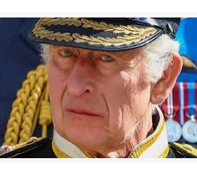

History

- What is a monarch and who is our monarch today?
- How did William the Conqueror become King of England and how did he rule?
- How did castles change?

RE
Islam: Who are Muslims and what do they believe?

- What do Muslims think about God?
- Who is the Prophet Muhammed and why is he important to Muslims?
- What is a mosque and what happens there?
- What happens at the celebration of Eid-ul-Fitr, and why?

Think, talk and ask questions about whether the story of Easter has anything to say to them about sadness, hope or heaven, exploring different ideas.

English-
‘The Emperor’s Egg
- To become familiar with the features of an information text
- To explore and develop ideas through discussion
- To research and create an information page

Science
Habitats
- Identifying and naming a variety of plants and animals in their habitats, including microhabitats.
- To know that most living things are suited to their habitat and where they live provides them with their basic needs.

Term 5

Learning in Year 2

PE
- Swimming
- Forest School

Maths-
- Fractions
- Measurement: length, height, capacity, mass and temperature
- Time – o’clock, half past, quarter past, quarter to.
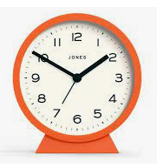

PSHE
Being my best:
- Keeping clean and healthy
- What does my body do?

Visitors, trips and Special Events

Drama workshop
Hemsley Conservation Centre
Forest School

Art
Printing and Design
- Design a print with simple lines and shapes
- Print using a polystyrene tile
- Choose their favourite artwork and make a whole class gallery

Computing
Robot algorithms

