Science
Seed Dispersal
To identify and describe the functions of different parts of flowering plants.

Learn the part that flowers play in the life cycle of flowering plants, including pollination, seed formation and seed dispersal.

Rocks and Soils
To describe different types of rock.

To compare rocks according to their appearance and properties

Music

Pitch shape
Folk songs

English
Narrative writing
‘The True Story of the Three Little Pigs’ and ‘Stone Age Boy’

Conjunctions, adverbial phrases, similes, metaphors, onomatopoeia

Year 3 learning in Term 1

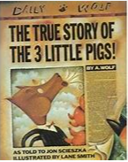

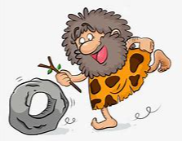
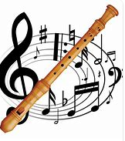
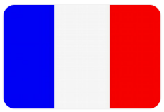
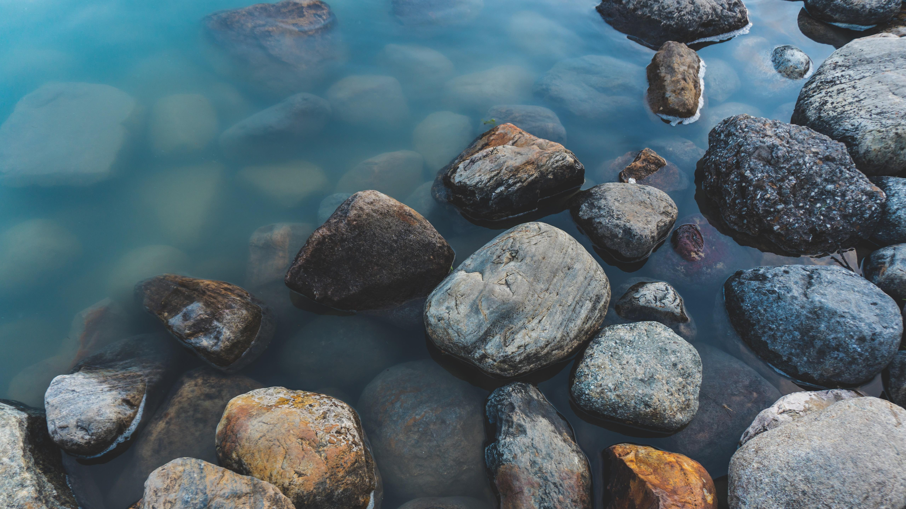
PE
Basketball
Yoga

Maths
Place Value
Addition
Subtraction
Recap 2, 5 and 10 times tables

Art/DT:

Painting and mixed media - Prehistoric painting

Discovering how and why our ancient ancestors made art, experimenting with natural materials to make homemade paints and playing with scale to paint on a range of surfaces.

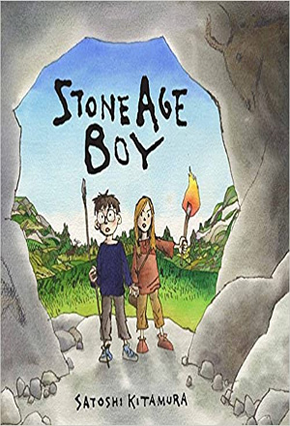
RE –
What is it like to follow God?
We will be learning about the links between the story of Noah and the covenant, as well as the links between the story and the promises made at a wedding ceremony.
We will link these ideas to how we live in school and the wider world.

PSHE
Me and My Relationships

Discussing children’s feelings as they make the transition from year 2. We will also be looking at the Zones of Regulation and how they can help us regulate our emotions.

French
Greetings
Name
Age
Birthday
Alphabet

Topic
History - Stone Age
We will compare the different periods of the Stone Age and how life changed over time.

Computing
Connecting computers, creating media, branching databases, sequencing music, events and actions.

