
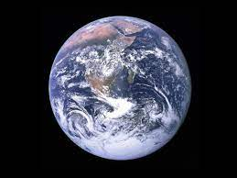 Science

- How do the planets and Earth move?
- How have ideas about the solar system changed over time?
- How does the moon move relative to the Earth?
- How do we have day and night?

English
Non-Chronological report- Mountains
Curiosity by Markus Motum Mars Rover explanations, logbooks, NASA proposals, news reports
Grammar
Spelling Book 1 Set 7-end



Year 5
Term 2 Learning
2025

Geography
What are Mountain regions like?
What are the features?
Where are they located using latitude and longitude?
How are they formed?
What is the climate like?



Music

RE
Incarnation: Was Jesus the Messiah?
- Why did the world need a saviour?
- What did the Jewish people expect the Messiah to be like?
- How does the Incarnation fit into the Big Story?
- Why did some Jewish people believe Jesus was the Messiah whilst others did not?
- What is the true meaning of Christmas?
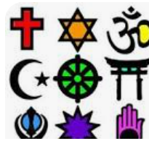

Maths
Addition and Subtraction
Multiples
Common multiples
Factors
Common factors
Prime, Square and Cube Numbers

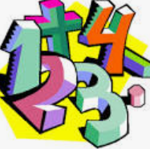

Music
Gospel Music
Identify key elements and instruments
Use musical vocabulary when talking about pieces.
Christmas songs

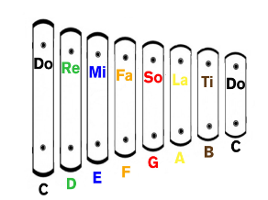

Enrichment
Space workshop
Planetarium
TEDS DAY
Christmas Carol Service

PE
PE with Wally Hall girls

Tag Rugby / Football


PSHE
- Recognising and celebrating we are all different.
- Identify different religions and cultures and celebrate their diversity.
- Influence and pressure of social media.
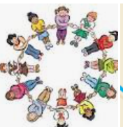

Art/DT

Retrofuturism

Space Art
Collograph printing

Computing
Creating Media
Vector Drawing
Safety online (linked to PSHE)



French
Healthy and unhealthy food

Christmas

