Year 4 Owl Class
Term 2 Learning
2025/26

English
- The River - Poetry
- Nikola Tesla – Biography
- Whole class reading
- Grammar
- Spelling Book 1 (Set 6-10)
- Autumn Term 2 Year 3/4 Common Exception words.

Science

Electricity

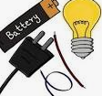

French

Numbers
Pencil case
Class objects
Colours
Christmas

Music

History
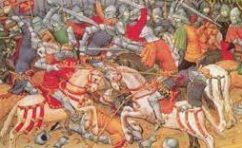
Anglo Saxons
“What was life like in Anglo-Saxon Britain?”

Visits/Visitors/trips

- TEDS Day
- DT day making torches
- KS1 Nativity
- Carol Concert

Maths

- Addition and Subtraction
- Multiplication and Division
- 3, 6, 7, 8, 9 times tables

Music

Violin/cornet/trumpet

The Pink Panther theme tune

RE
Incarnation
“What is the Trinity?”
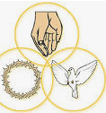

PE 
- Swimming
- Tag Rugby
- Football

PSHE

Valuing difference:
Recognising and celebrating difference (including religions and cultural difference)
Understanding and challenging stereotypes

DT
Electrical systems: Torches

Electrical products
Evaluating Torches
Torch design
Torch assembly

Computing
Creating media – audio production



