Year 3 learning in Term 2

English
Persuasive advert writing around the story of Ug – ‘Boy Genius of the Stone Age’
Writing our own version of a poem based on festivals
Repeated refrains, verse and personification

Science
Rocks & Soils
How rocks are formed.
The way rocks can be classified according to their properties.
Fossils - how they are made.
Investigations to test rocks and soils.

Music
Singing – using pitch, tone and tempo
perform to an audience
Christmas Songs

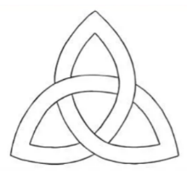
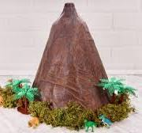
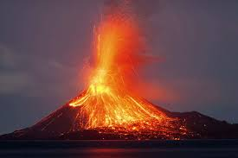


Art/DT:

Constructing a volcano
We will be learning about solid structures. The children will design and make a volcano, by carefully selecting materials in order to create solid structures ready for eruption!

PE

Dance
Tag rugby/
Football

Maths
Addition
Subtraction
Multiplication and Division

RE
What is the Trinity? What do we learn about the Trinity from Jesus’ baptism? What is the role of the Father, Son and Holy Spirit?

Topic- Geography

Why do people live near Volcanoes?

ICT

Creating media through animation

PSHE - Emotional Health

Valuing Difference
Recognising and respecting diversity
Being respectful and tolerant
My community

French

11-20
Pencil Case
Colours
Christmas

