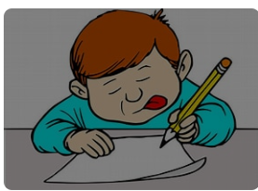
English

MYTHS
Writing a myth

A Shot in the Dark
Theseus and the Minotaur/Pandora’s Box

History
What did The Greeks ever do for us?

Who were the Greeks and when did they live?

How was ancient Greece governed?

Did the ancient Greeks give us democracy?

How do Greek philosophers influence us today?

Enrichment : Greek Day

Science

Materials

Separating solutions and mixtures
Reversible and irreversible changes


Year 5
Term 3 Learning
2025

Music

Music

Introduction to song writing
Structure (verse/chorus), hook, lyric writing, melody



Maths

Fractions
Multiplication methods
Division methods

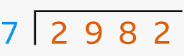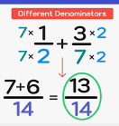

RE
People of God
Who is Moses?
What is the Exodus?
The Commandments – what and why?
How can we put our beliefs into practice?
How does following God bring freedom and justice?

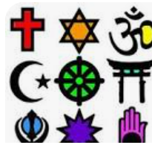

PE


Gymnastics (Thursday)
Fitness and Forest School (Friday)

PSHE
Keeping Safe
Managing Risks
Online Safety
Use of legal drugs – tobacco and alcohol
Decision making skills

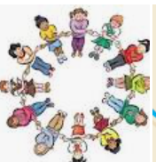

Computing
Creating vectors - graphics
Creating media- video production



French

Pets
On the Farm
At the zoo


DT

Structures : Bridge Building



