
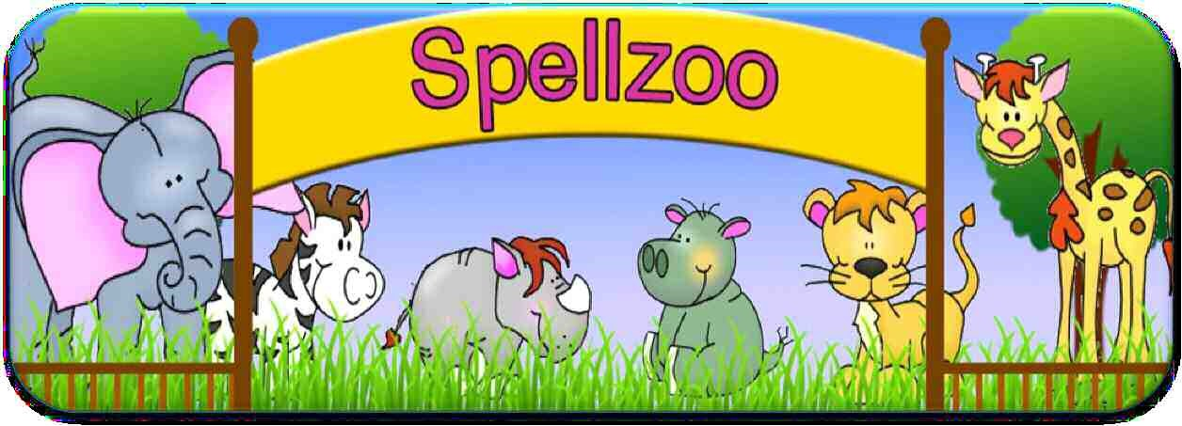
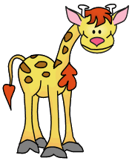
Book 2
Year
5
Sets 1
–
10

Weekly spellings
Look, Say, Cover, Write Check

Set 1: Words ending in ‘able’
 | 1st try | 2nd try
measurable
irritable
understandable
fashionable
accountable
deliverable
disagreeable
suitable
portable
considerable
communicate
competition

Set 2: Words ending in ‘cible’ and ‘gible’
 | 1st try | 2nd try
invincible
forcible
eligible
tangible
legible
negligible
submergible
illegible
intangible
unintelligible
conscience
conscious

Set 3: Words ending in ‘ceable’/‘geable’
 | 1st try | 2nd try
unpronounceable
unnoticeable
irreplaceable
rechargeable
interchangeable
unmanageable
exchangeable
forgeable
salvageable
knowledgeable
dictionary
equipped

Set 4: Words ending in ‘fer’ with a suffix
 | 1st try | 2nd try
referred
transferred
preferred
referee
reference
preference
transference
conferred
conference
deferred
curiosity
definite

Set 5: Words with a hyphen
 | 1st try | 2nd try
re-cover
re-enter
co-operate
co-ordinate
co-own
co-host
re-create
re-elect
co-driver
pre-owned
harass
foreign

Set 6: Words with ‘cei’
 | 1st try | 2nd try
ceiling
deceive
receive
perceive
receipt
misconceive
conceit
deceit
receiver
inconceivable
controversy
convenience

Set 7: Words with ‘ough’
 | 1st try | 2nd try
tough
cough
bough
though
through
nought
brought
thorough
rough
enough
correspond
criticise

Set 8: Words with silent letters
 | 1st try | 2nd try
thistle
whistle
island
knight
knife
kneel
lamb
comb
climb
doubt
desperate
determined

Set 9: Homophones 1
 | 1st try | 2nd try
board
bored
serial
cereal
where
wear
mail
male
knight
night
great
grate
key
quay
pane
pain
scent
sent
disastrous
embarrass

Set 10: Homophones 2
 | 1st try | 2nd try
pair
pear
knew
new
pail
pale
road
rode
rowed
you
yew
ewe
side
sighed
heard
herd
piece
peace
environment
equipment

