Science

Animals including Humans
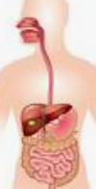

History
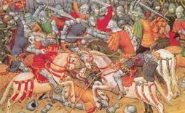
Vikings
“What was the impact of the Vikings invading Britain?”

English
- Narrative quest: Arthur and the Golden Rope

- Whole class reading
- Grammar
- Spelling Book 2 (Set 1-5)
- Spring - Term 3 Year 3/4 Common Exception words.

Year 4 Owl Class
Term 3 Learning
2025/26

French

Pets
At the zoo
On the farm

Music

Visits/Visitors/trips

- Viking Day

Music

Violin/cornet/trumpet

The doot doot song

Maths

- Multiplication
- Division
- Shape
- Times tables

RE
Gospels
“What kind of world would Jesus want?”
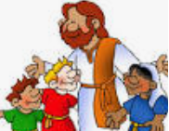

PE 
- Gymnastics
- Outdoor and Adventurous Activities

Art/DT
Mechanical systems: Pneumatic toys

Exploring pneumatics
Designing a pneumatic toy
Making pneumatic toys
Decorating and assembling my toy

PSHE

Keeping Myself safe
Managing risk
Understanding the norms of drug use (cigarette and alcohol use)
Influences
Online safety

Computing
Creating media – photo editing



