Year 3 learning in Term 3

English
Narrative:
The Scarab Secret – writing own version of the story.
The Egyptian Cinderella – making comparisons with traditional tales and writing our own version of a traditional tale.

Science- Forces & Magnets
Compare how things move on different surfaces.
Know that magnets have two poles.
Understand that forces need contact between two objects but magnetic forces can work at a distance.
Observe how magnets attract and repel each other.
Identify magnetic materials

Music

Latin dance music

PE

Gymnastics

Swimming

PSHE

Keeping Safe
Managing risk
Decision-making skills
Drugs and their risks
Staying safe online

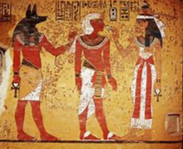
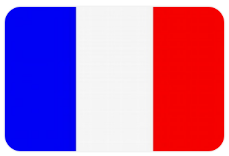
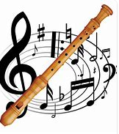
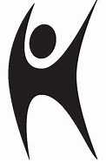
Art/DT:

Textiles: Egyptian collars

We will be using cross-stitch and appliqué to decorate and assemble our very own Egyptian Usekh /Wesekh collars.

Topic- History

Ancient Egypt- Who were the Egyptians and when did they live?
What did the Ancient Egyptians believe?
French

Pets
At the zoo
On the farm

RE
Humanism
What do Humanists value?
Why is happiness important to Humanists?
What do Humanist wedding ceremonies tell us about their values?
What do Humanists believe about making a difference?

ICT

Creating media – desktop publishing

Maths
Multiplication and division

Length and perimeter

4 & 8 times table

