Geography
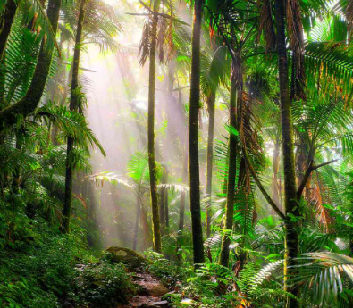
Rainforests
- Locating using maps
- Human and physical features
- Climate
- Issues in the rainforest

Science

Sound
- Pattern seeking
- Using data loggers


English
- Travel guide for Borneo rainforest
- The Sound Collector poetry
- Whole class reading
- Grammar
- Spelling Book 2 (Set 6-10)
- Spring - Term 4 Year 3/4 Common Exception words.

Year 4 Owl Class
Term 4 Learning
2025/26

Music

Visits/Visitors/trips

- Liquid Nitrogen Show
- Science day
- World book day
- The Lion King

Music

Violin/trumpet lessons

Fanfare for the common man

Maths
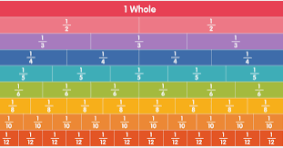
- Division
- Fractions
- Decimals
- Times tables

RE
Salvation
“Why do Christians remember the events of Holy Week every year?”


PE 
- Dance
- Indoor cricket at Sevenoaks School

PSHE

Rights and Respect
- Who helps us stay healthy and safe?
- Our rights
- How do we make a difference?

Art
Craft and design:
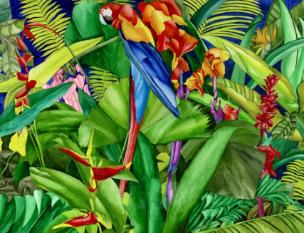

Fabric of Nature

French
Brothers and sisters
Family
Hair and eyes

Computing
Photo editing
Programming repetition in shapes



