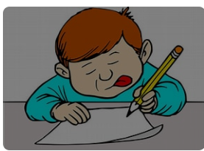
English

Poetry:
“I Rise” by Maya Angelou

Persuasive Texts:
- Speeches
- Pitch letters

Science
Understanding Forces

- Gravity
- Air resistance, water resistance and friction
- Levers, pulleys and gears

Geography
Time Zones
- Day and night
- World time zones
Why do oceans matter?
Where are the worlds’ oceans and how do the influence climate?
How do we use our oceans?
Why are our oceans suffering?
What can we do to help our oceans?

Year 5
Term 4 Learning
2026

Music

Music

“Building a Groove”

Medina tun Nabi beats
Focussing on baselines and riffs encompassing beat and rhythm
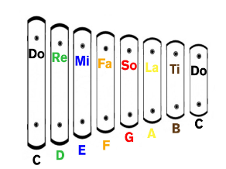

Maths
Consolidating multiplication and division methods.

Fractions: multiplying fractions, finding fractions of amounts and finding the whole

Decimals and Percentages

Angles and co-ordinates



RE
Salvation
What did Jesus do to save human beings?
- What were the main events of the Easter story ? Stations of the Cross
- Who was responsible for Jesus’ death?
- Why did he die?
- Why is the Eucharist important to Christians?
- What does sacrifice mean to Christians?

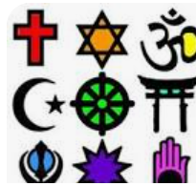

PE

Wally Hall PE on Tuesdays


Basketball on Fridays

PSHE
Right, respect and responsibility
Fact or opinion
Rights and duties
Spending wisely
Lend me a fiver

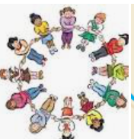

Computing

Data and Information –
Flat–file databases



French

Brothers and sisters
Family
Hair and eyes



DT
Food – Adapting and following a recipe
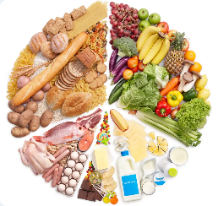

- Recipe reading
- Nutritional value in foods
- Knife skills

