Music

classical music

Science
Animals including Humans
To know that animals and humans need the right amounts and types of food, to understand and explore animal diets, to know that humans and some animals have skeletons and muscles for support, protection and movement.
English
Writing explanation texts on mummification of tomatoes.
Writing non-chronological report on skeletons and muscles.

Year 3 learning in Term 4


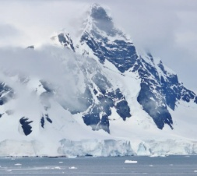
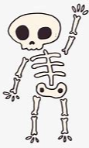
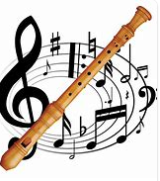
Topic- Geography

What is it like in Antarctica? Who lives in Antarctica?
Can I plan and follow a simple route on a map using compass points?

ICT

Publishing
Data and information – branching databases

PE

Basketball
Forest school

Maths
Perimeter and length
Fractions
Money

Art/DT:
Textiles: Egyptian collars

We will be completing our collars using cross-stitch and appliqué to decorate and assemble our very own Egyptian Usekh /Wesekh collars.

French

My Family.
Describing myself and others.

PSHE
Rights and Respect
Skills we need to develop as we grow up
Helping and being helped
Looking after the environment
Managing money

RE
Salvation
Why do Christians call the day Jesus died, ‘Good Friday’? We will examine the significance of the Easter Story.

