Visits/Visitors and trips
Christmas Show at the Ship Theatre
Watch a pantomime
Space Exhibition in the school hall

Phonics
Phase 2 continued
Blend cvc words containing phase 2 phonemes
Segment cvc words containing phase 2 phonemes
Read tricky words
Read words with s /s/ added at the end (hats sits)

Knowledge and Understanding of the World
RRecognise a map and
understand what it is used for
Understand changing states of
matter
Understand how
environmental damage affects
the Earth
Know some similarities and
differences between the
natural world around them and
contrasting environments
Discuss differences in religious
beliefs and traditions
Talk about other countries in the
World
Understand that other people have
different customs in their home
and families
Understand that some places are
special to members of their
community
Recognise that people have
different beliefs and celebrate
special times in different ways

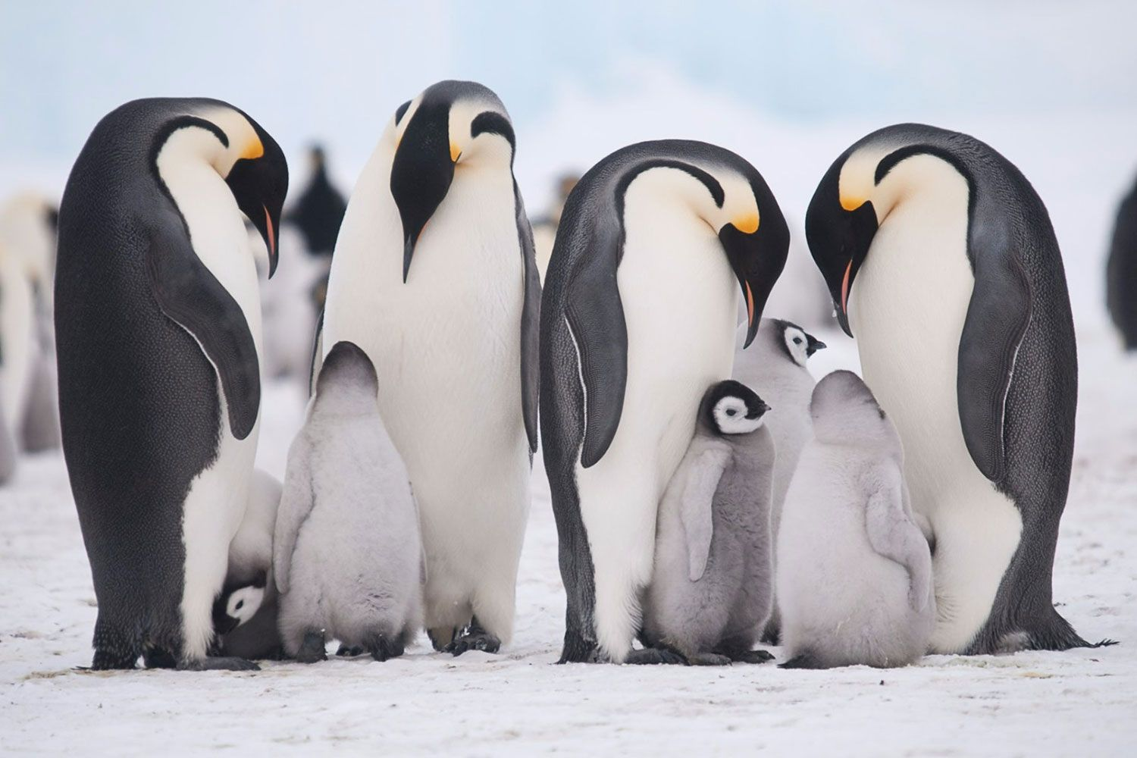
RE
INCARNATION
‘Why do Christians perform Nativity plays at Christmas?’
Understand that Christians believe
Jesus was a special baby
Know the main people in the Nativity
Retell the Nativity story

Personal Social and Emotional Development
Know how to celebrate differences
Talk about family life
Be kind, caring and helpful to others
Show good listening
Listen to others and learn about their lives

Expressive Arts and Design
Use tools safely and appropriately to make models
Listen to music and make up own dances in response
Perform songs to an audience
Participate in role play activities
Experiment with colour mixing with a variety of media
Sing in a group or on their own, increasingly matching the pitch and following the melody

Maths
Represent 1, 2 & 3
Compare 1, 2, & 3
Investigate the composition of 1, 2 & 3
Circles and triangles – identify, describe, replicate
Use and understand positional language
Represent 1-5
Find one more and one less
Recognise, name and sort shapes with 4 sides
Use language related to time

Communication & Language
Develop vocabulary and use in conversation
Retell stories
Understand and follow instructions
Take part in discussions with one other person
Join in with small group discussions
Join in with songs and rhymes
Perform to an audience

Literacy
Retell stories using images
Orally retell stories
Enjoy an increasing range of books
Understand the five key concepts about print: - print has meaning - print can have different purposes - we read English text from left to right and from top to bottom - the names of the different parts of a book
Non-fiction texts:
Penguins/Polar Bears/ Children’s Atlas
Focus texts:
Lost and Found
The Emperor’s Egg
Poles Apart
You’re Snug With Me

Physical Development
Fine Motor:
Develop muscle tone to put pencil pressure on paper
Use tools to make changes to materials
Show preference for dominant hand
Begin to form letters
Gross Motor:
Move safely and sensibly in a space and stop with control
Use equipment safely and responsibly
Travel in different ways

Term 2 Learning
It’s freezing!
Year R
Squirrel Class

