Physical Development
Fine Motor:
Hold pencil effectively with comfortable grip to form recognisable letters
Do clothes fastenings
To use playdough to represent alterative objects
Gross Motor:
Explore different body parts and how they move
Move and remember different actions
Express and communicate ideas through movement exploring directions and levels
Move with control and coordination

RE
Why do Christians put a cross in an Easter garden?

Salvation
The Good Samaritan
The Easter Story – Good Friday, Easter Sunday

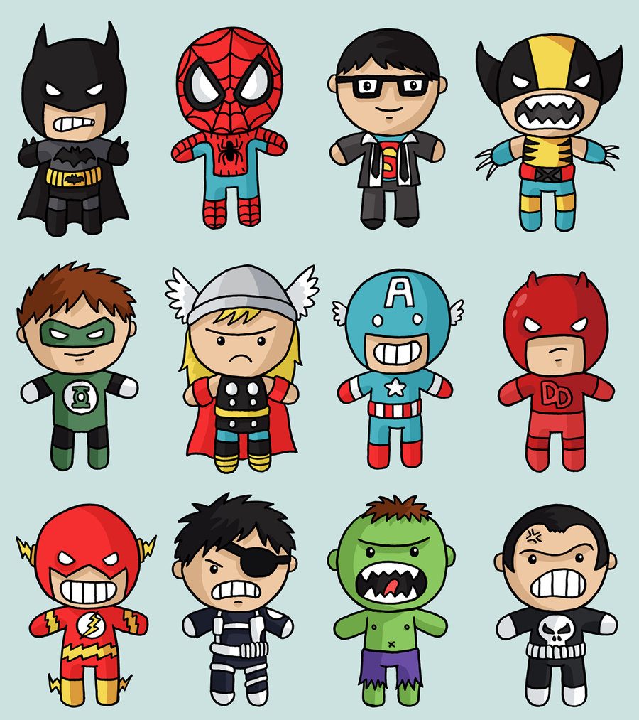
Communication & Language
Use social phrases
Use talk to work out problems and organise thinking
Use talk to explain how and why things may happen
Listen to and talk about books to develop a deep familiarity with new knowledge and vocabulary

Maths
Compare capacity
Represent, compare and investigate the composition of 9 & 10
Compare numbers to 10
Begin to know bonds to 10
Recognise, name and sort 3d Shapes
Explore patterns

Visits/Visitors and trips
Superhero challenge day
Trip to Sevenoaks Bookshop
Science & World Book Day

Knowledge and Understanding of the World
Explore the natural world around them
Describe what they see, hear and feel whilst outside
Think about variables in an investigation
Understand the effect of changing seasons on the natural world around them
Understand the term pollution and talk about the effects
Be able to talk about how to protect the planet
Understand the role humans have in protecting the planet
Begin to draw pictures of animals and plants.

Personal Social and Emotional Development
Understand that we need to exercise to keep our bodies healthy
Know which foods are healthy and not so healthy and can make healthy eating choices
Understand that they can make a difference
Identify how they can care for their home, school and special people

Expressive Arts and Design
Experiment with printing and collage techniques
Attempt observational drawings – pencil, close up detail
Share creations explaining the process
To hold a paintbrush with a traditional grip
To evaluate and select the best adhesive to sticks things on a collage

Phonics
Blend cvc words containing phase 3 phonemes
Segment cvc words containing phase 3 phonemes
Read tricky words
Read words with two or more digraphs
Read longer words words ending in –ing Read compound words
Read longer words words with s in the middle /z/ s words ending –s words with –es at end /z/

Literacy
Write correctly formed letters
Write compound words
Describe using adjectives
Independently write captions and labels Independently write simple sentences
Begin to use finger spaces
Key Texts:
Supertato – Sue Hendra
Three Little Superpigs –
Super Bat – Matt Carr
Super Daisy - Kes Gray
George Saves the World at Lunchtime - Jo Readman
The Marvel Encyclopedia

Term 4 Learning

Superheroes!

Year R

