
History
World War Two
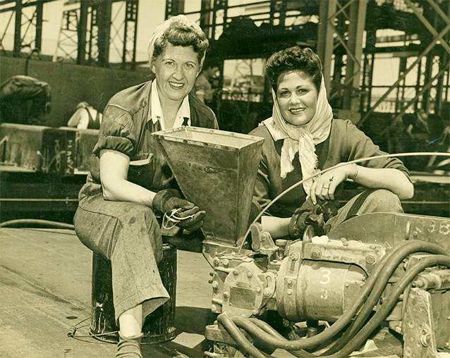

What was the impact of WW2 on British people?

Term 2
Year 6

Design Technology
The Steady Hand Game
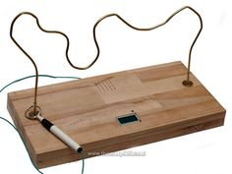

Science
Electricity
Building Circuits
Drawing electrical diagrams
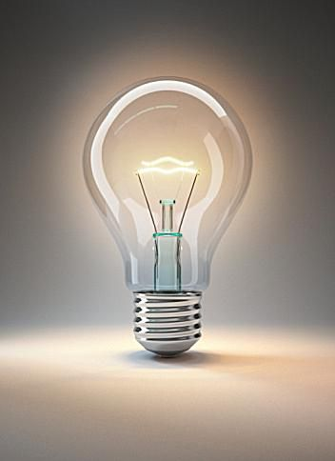

PSHE
Recognising and celebrating difference
Recognising and reflecting on prejudice-based bullying
Understanding bystander behaviour
Gender stereotyping

Visits/Visitors/trips
- Horton Kirby WW2

Music
Introduction to song writing Structure, hook, lyric, melody. Touch the Sky Folk music, pentatonic scale


PE
- Dodgeball
- Tag Rugby
- Football
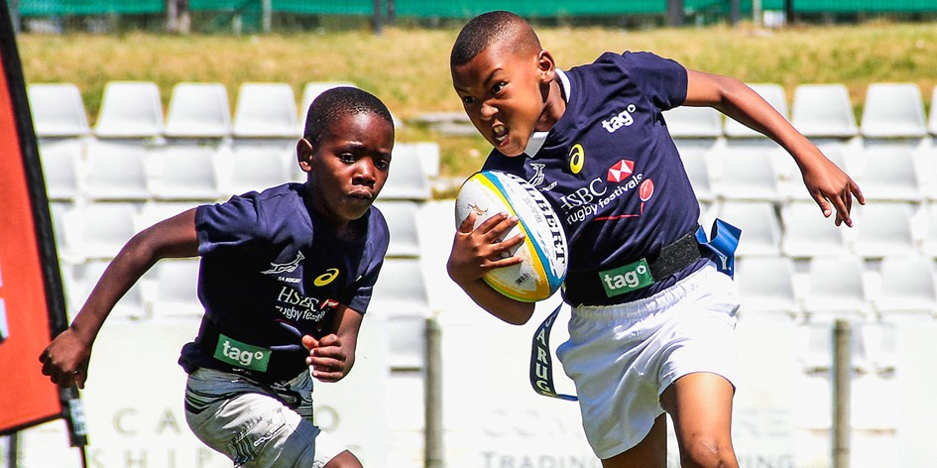

Computing

Creating Media – 3D modelling

RE
The Gospels
How do the messages in the Gospels impact on Christians?


French
Numbers
Pencil Case
Class objects
Colours
Christmas

Maths
- Order of Operations
- Fractions
- Converting Units
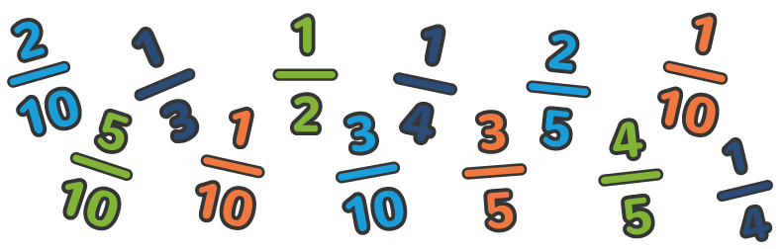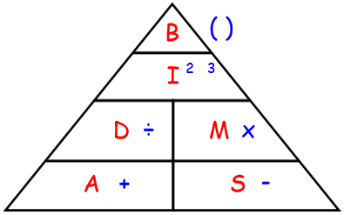
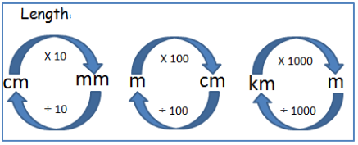

English
Letters from the Lighthouse
Speech – World War 2



