
English

Firework Maker’s Daughter
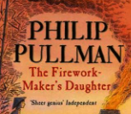

Geography
Where does our energy come from?
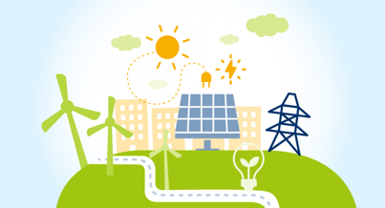

Term 3
Year 6

Design Technology
Textiles – Design and make a waistcoat for a toy.


Science
Light

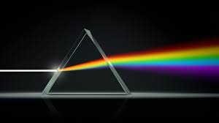

PSHE
Understanding emotional needs
Staying safe online
Drugs: norms and risks (including the law)
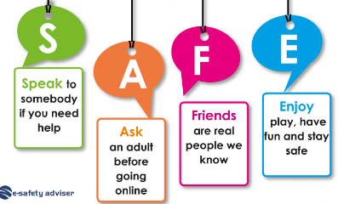

Visits/Visitors/trips

Music
Dona nobis pacem
Church music in Latin
You to me are everything
70s soul music


PE
- Gymnastics
- Tennis
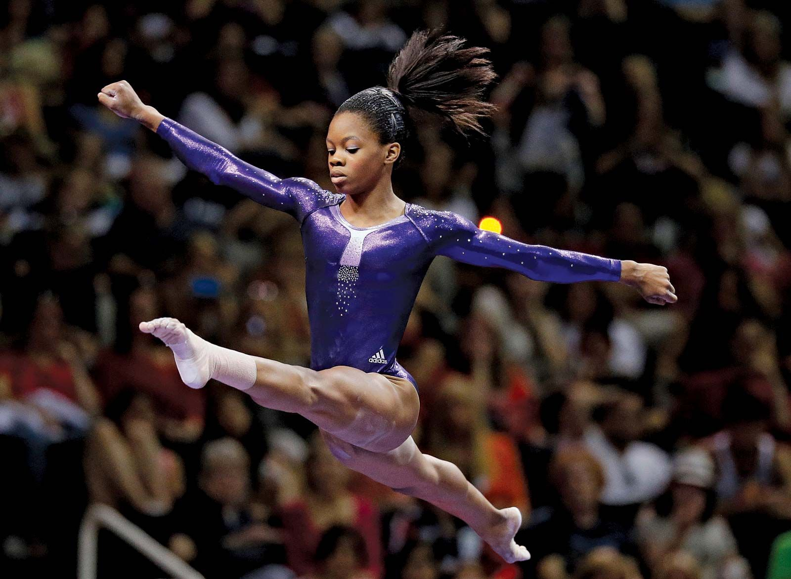

Computing
Creating Media – web page creation

RE

Humanism

French
Pets

At the Zoo

On the Farm

Maths
- Ratio
- Algebra
- Decimals


