
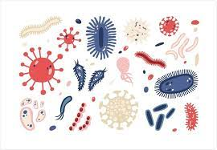
History
World war 2

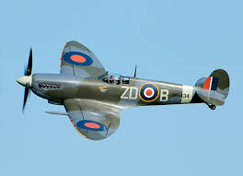

PSHE
Keeping Safe
Drugs / alcohol: categories, law, effects, risks

Rights and Respect
Media, social media, money

PE
- Tennis
- Dodgeball


Maths
- Fractions, Decimals, Percentages
- Area, Perimeter, Volume
- Statistics

Computing
Variables in games

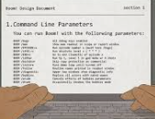

Visits/Visitors/trips
Lion King

Term 4
Year 6

Science
Living Things
We will look at different species including microorganisms.

Music
Building a Groove Beat rhythm, basslines, riff
Ain’t gonna let nobody
USA – civil rights, gospel, rhythm, blues & choral

RE
Judaism
What does it mean to be Jewish in Britain today?

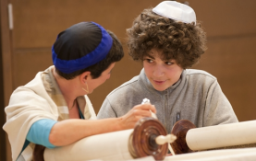

French
Brothers and sisters
Family
Hair and eyes


English

Letters from the Lighthouse

