RE
What can we learn from Old Testament stories?
Noah’s Ark
Abraham and Sarah
Jacob and Esau
Joseph and his dream coat

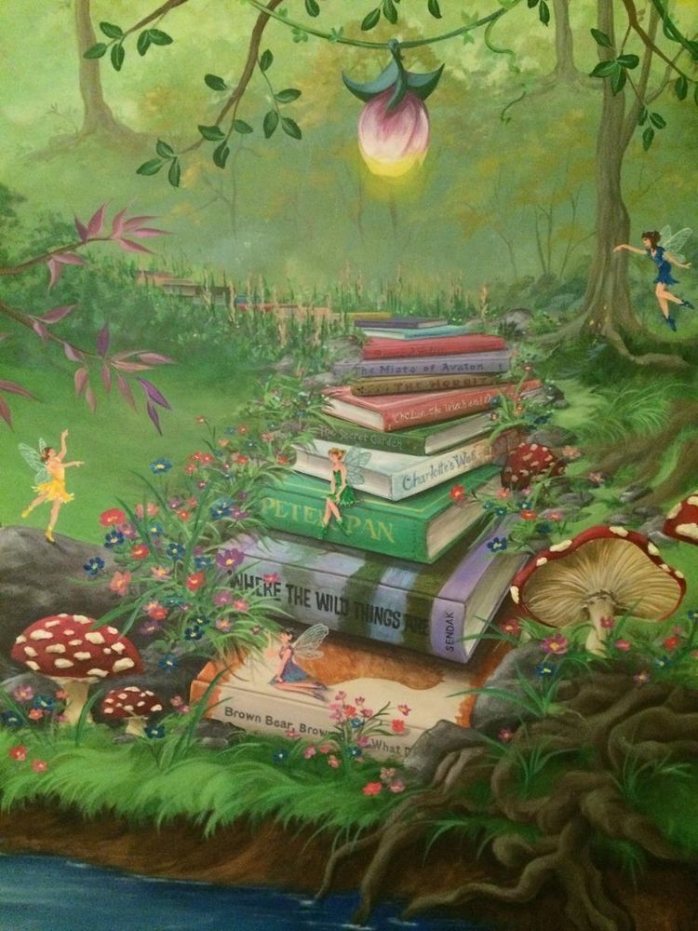
Expressive Arts and Design
Create own music.
Explore 3d relief art techniques
Invent narratives with peers
Develop storylines in their pretend play
Evaluate own art work and that of famous artists
To know how to mix secondary colours and different shades of the same colour.
Selecting the right materials and methods for effect.

Phonics & Reading
Read words with short vowels CVCC CCVC
Read words with short vowels CCVCC CCCVC CCCVCC longer words
Learn root words ending in: –ing, –ed /t/, –ed /id/
/ed/ –est
Retell a story with actions and / or picture prompts as part of a group
Use story language when acting out a narrative

Physical Development
Fine Motor:
Develop pencil grip and letter formation continually
Use one hand consistently for fine motor tasks
Start to cut along a curved line, like a circle
Use a prepared needle and wool to practise threading
To know that threading is putting one material through an object
Explore alternative malleables to playdough
Gross Motor:
Develop rolling a ball to a target
Develop stopping a ball
Develop accuracy when throwing to a target
Develop bouncing and catching a ball
Develop dribbling and kicking a ball
Develop athletic skills

Personal Social and Emotional Development
Think of ways to solve problems to stay friends
Start to realise the impact of unkind words
Feel resilient and confident in learning
Name and discuss different types of feelings and emotions
Learn and use strategies or skills in approaching challenges
Understand how to make healthy choices
Name and recognise how healthy choices can keep us well

Knowledge and Understanding of the World
Know some similarities and differences between things in the past and now, drawing on their experiences and what has been read in class
Understand the past through settings, characters and events encountered in books read in class and storytelling
Explain some similarities and differences between life in this country and life in other countries
Draw pictures of animals and plants taking note of some features

Term 5 Learning

Once Upon a Time...
Year R

Literacy
Retell a story with actions and / or picture prompts as part of a group
Use story language when acting out a narrative
Explain the main events of a story - Draw pictures of characters/ event / setting in a story
Key Texts:
Jack and the Jellybean Stalk Cinderella
No Dinner Rapunzel
Princess and the Pea

Maths
Build numbers beyond 10
Count patterns beyond 10
Spatial reasoning – match, rotate and manipulate
Add more to a given number
Take away from a given number
Spatial reasoning – compose and decompose

PE
Dance
Athletics

Communication & Language
Use language to describe
Use new vocabulary in different contexts
Retell stories, once they have developed a deep familiarity with the text, some as exact repetition and some in their own words

