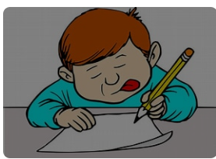
English

Street Child – Berlie Doherty

Narrative Poetry: The Highwayman

Whole class reading
Grammar: using parenthesis, colons and dashes; relative clauses

Spelling Book 3

Science

Living Things
Observing and comparing life cycles of plants and animals.


History

The Victorians

What was life like?
- Inventions

What does the census tell us about the people living in our local area?

Year 5
Term 5
Learning
2026

Music

Music

Gamelan from Bali

Interlocking
rhythm vocal chant musical cycles
pentatonic scales

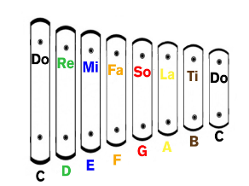

Maths

Decimals and percentages
Measures
Time
Consolidation



RE
Islam
What does it mean to be a Muslim in Britain today? Part 1
The Five Pillars
Key beliefs and how these influence believers’ lives


PE
Swimming (Tuesday)
Athletics (Thursday)



PSHE

Growing independence and taking responsibility
Keeping myself healthy
Media awareness and safety
My community



Enrichment/visits

Quebec House – Foundling Museum

PGL Residential

Debating

Computing
Flat-file databases
Selection in quizzes



Art - Architecture

Craft and design


Observational drawing
Using the work of Hundertwasser as inspiration.

French

Weather
Ice cream
Snacks

