
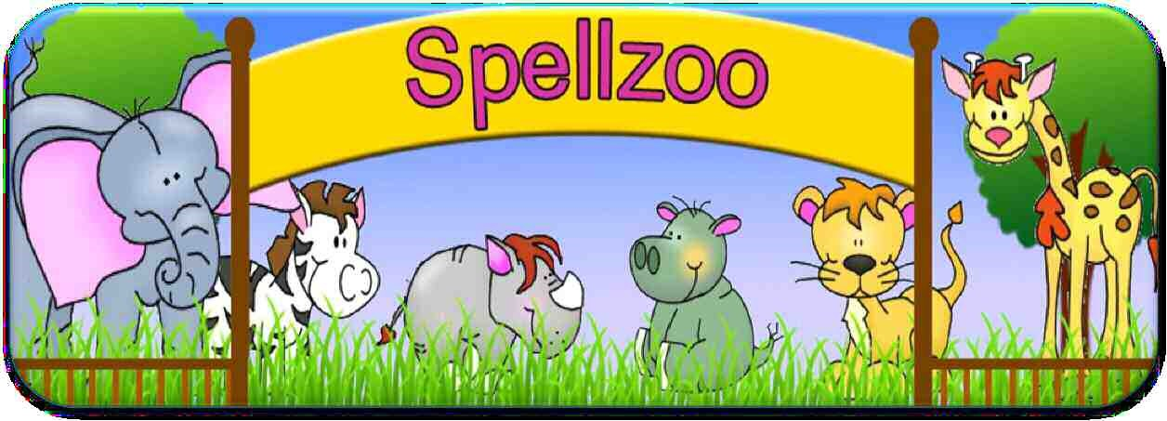
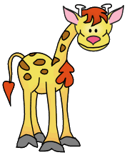
Book 3
Year
5
Sets 1
–
10

Weekly spellings
Look, Say, Cover, Write Check

Set 1: Homophones ending in 'ce' (nouns) and 'se' (verbs)
 | Write these in a sentence:
advise
advice
devise
device
licence
license
practice
practise
 | 1st try | 2nd try
especially
exaggerate

Set 2: Homophones 2
 | Write these in a sentence:
blue
blew
waste
waist
sew
so
sow
or
ore
oar
 | 1st try | 2nd try
existence
familiar

Set 3: Homophones 3
 | Write these in a sentence:
aisle
isle
aloud
allowed
affect
effect
our
hour
bridal
bridle
 | 1st try | 2nd try
forty
frequently

Set 4: Homophones 4
 | Write these in a sentence:
led
lead
cell
sell
cereal
serial
passed
past
draught
draft
 | 1st try | 2nd try
guarantee
hindrance

Set 5: Homophones 5
 | Write these in a sentence:
flower
flour
morning
mourning
decent
descent
dessert
desert
stationary
stationery
 | 1st try | 2nd try
identity
immediately

Set 6: Homophones 6
 | Write these in a sentence:
guessed
guest
steal
steel
principal
principle
compliment
complement
who's
whose
 | 1st try | 2nd try
individual
interfere

Set 7: Recommended words 1
 | 1st try | 2nd try
accommodation
communication
equipment
interruption
profession
symbol
committee
environment
interfere
privilege
language
leisure

Set 8: Recommended words 2
 | 1st try | 2nd try
language
lightning
temperature
vegetable
bruise
ancient
excellent
muscle
necessary
neighbour
marvellous
muscle

Set 9: Recommended words 3
 | 1st try | 2nd try
awkward
determined
familiar
foreign
government
guarantee
opportunity
parliament
physical
queue
mischievous
necessary

Set 10: Revision
 | Write these in a sentence:
practice
practise
affect
effect
compliment
complement
 | 1st try | 2nd try
environment
excellent
necessary
parliament
neighbour
opportunity

