English
- Instruction writing
- Granny came here on the Empire Windrush
- Whole class reading
- Grammar
- Spelling Book 3 (Set 1-5)
- Summer - Term 5 Year 3/4 Statutory Spelling words.

Geography
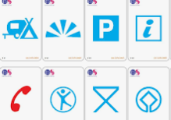

- “Are all settlements the same?”

Science

Living things and their habitats

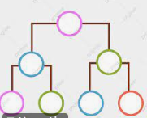

Year 4 Owl Class
Term 5 Learning
2025/26

Music

Visits/Visitors/trips

- Earth Day
- Forest School
- CATS tests (date to be confirmed)
- Sharing afternoon

Music

Violin/cello lessons
Global pentatonics

Maths
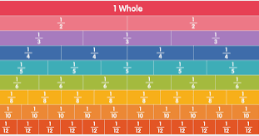
- Fractions
- Decimals
- Money
- Times tables

RE
Hinduism
“What does it mean to be a Hindu in Britain?”


PE

- Athletics
- Forest school

PSHE

Being my Best
- Having choices and making decisions about my health
- Taking care of my environment
- My skills and interests

Art

Painting & mixed media light & dark
- Tints & shades
- 3 dimensions
- Painting techniques
- Painting composition
- Still life

French
Weather
Ice cream
Snacks

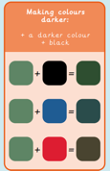
Computing
Data logging and repetition in shapes




