Music
Recorders.

English
Writing setting descriptions, writing in character, writing recounts. Based around Escape from Pompeii.

Science- Plants
To recognise what plants need to live and grow.
To investigate how water is transported within plants.
To explore the role of flowers in the life cycle of plants.

Year 3 learning in Term 5

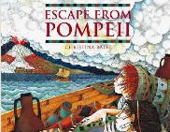



Art/DT:

Mosaics – looking at Roman Mosaics and designing and creating our own.

French

At the Market
And Supermarket
Snacks

Maths
Mass and capacity
Money
8 times tables

RE
Kingdom of God

What was the impact of Pentecost?

Topic- History
Who were the Romans and why did the invade Britain?

PE

Athletics
OAA team games.

PSHE
Being my Best
Keeping myself healthy and well
Celebrating and developing my skills
Developing empathy

ICT

Branching databases

