Expressive Arts and Design
Perform to an audience
Evaluate and discuss music
Return to and build on previous learning, refining ideas and developing their ability to represent them
Begin to show accuracy and care when drawing

Phonics
Read long vowel sounds CVCC CCVC
Read long vowel sounds CCVC CCCVC CCV CCVCC
Read Phase 4 words ending –s /s/ Phase 4 words ending –s /z/ Phase 4 words ending –es longer words
Learn root word ending in: –ing, –ed /t/, –ed /id/ /ed/, –ed /d/
Learn root word ending in: –er, –est Read longer words

RE
What stories are told by and about people of other faiths and beliefs?
Jewish faith – Story of Jonah
Muslim faith – Tiny Ants and The Thirsty Camel
Hindu faith – Rama and Sita and The Pearls and the Crow

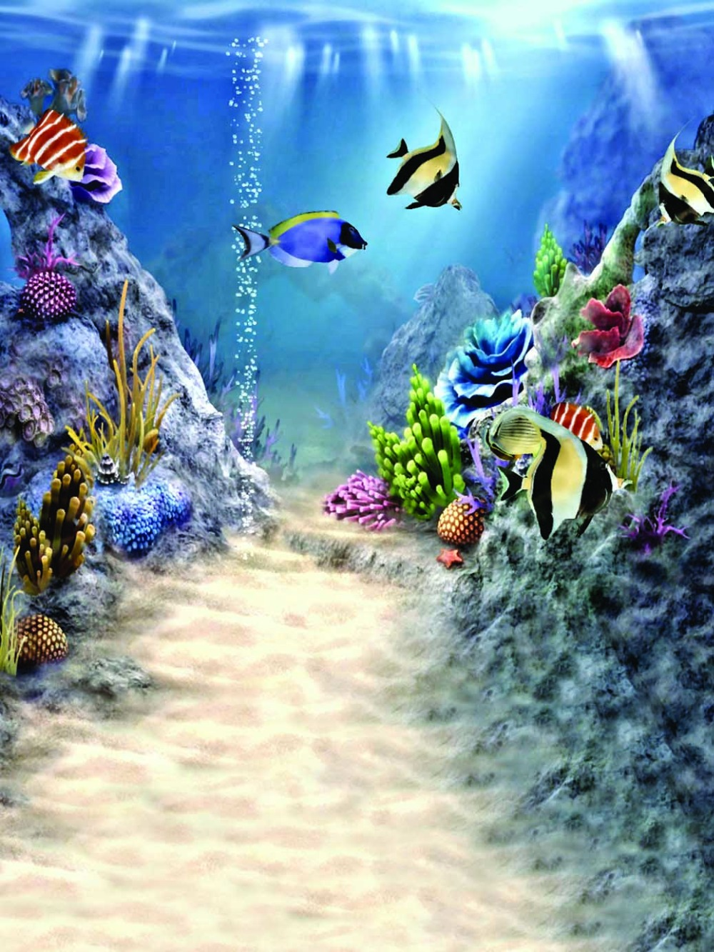
Communication & Language
Describe events in detail
Use talk to help work out problems and organise thinking and activities, and to explain how things work and why they might happen
Articulate their ideas and thoughts in well-formed sentences

Literacy
Write a story
Write sentences using a range of tricky words that are spelled correctly
Begin to use full stops and capital letters
Use familiar texts as a model for writing own stories
Key Texts:
Somebody Swallowed Stanley – Sarah Roberts
The Big Book of Blue – Yuval Zommer
Commotion in the Ocean – Lucy Cousins
Rainbow Fish – Marcus Pfister
Where the River Meets the Sea – Jeannie Baker

Visits/Visitors and trips
London Aquarium
Sports Day
Transition days to year one

Maths
Begin to double numbers and amounts
Share and groups objects and numbers
Begin to know and understand the concept of even and odd
Spatial reasoning – visualise and build
Spatial reasoning - mapping

Personal Social and Emotional Development
Name parts of the body
Understand that there are changes in nature and humans
Name the different stages of childhood and growing up
Express feelings about year one
Share memories of the best bits of school so far

Physical Development
Fine Motor:
Form letters correctly
Fasten clothes – zips and buttons independently
Use pincer grip effectively
Show good hand to eye coordination
Show good control with small tools – pens, paintbrushes, needles
Gross Motor:
Play games showing an understanding of the roles within it
Follow instructions and move safely when playing in a team
Work with others to play team games
Use a variety of equipment safely
Term 6 Learning

Under the Sea
Year R

Knowledge and Understanding of the World
Understand how environmental damage affects the earth
Identify ways that countries and landscapes change over time
Understand the term pollution and its effect
Understand the role humans have in damaging the environment
Make observations and draw pictures of plants and animals
Locate countries with significant oceans
Talk about how we have all changed since stating school

