History

- “How have children’s lives changed?”

Science

Living things and their habitats

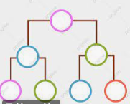

English
- Narrative writing – Charlie and the Chocolate Factory
- Whole class reading
- Grammar
- Spelling (words will be on planner slips)
- Summer - Term 6 Year 3/4 Common Exception words.

Year 4 Owl Class
Term 6 Learning
2025/26

Music

Visits/Visitors/trips

- Sports Day
- Steve Backshall Oceans live lesson
- Year 4 Residential – 2nd and 3rd July

Music

Violin/trumpet/cornet lessons

Maths
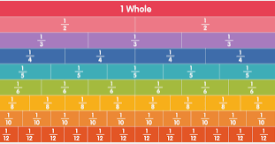
- Money
- Time
- Four operations revision

RE
Why do some people think life is a journey?



PE 
- Athletics
- Cricket
- Rounders

PSHE

Growing and changing
- Anticipating body changes during puberty
- Managing difficult feelings
- Relationships including marriage


DT

Cooking and nutrition: Adapting a recipe
- Follow a recipe with support
- Use a budget to plan a recipe
- Evaluate our products

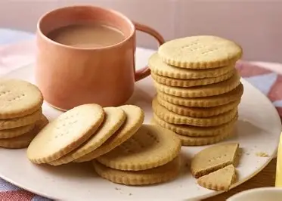

French
Weather
The Body
At the Doctors

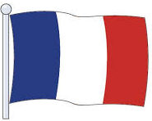
Computing

Repetition in games

