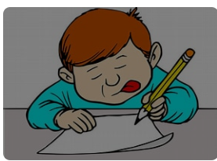
English
The Princess Blankets by Carol Ann Duffy :
- Letter writing
- Newspaper reports
- Debates
- Descriptions
- Narratives
Whole class reading
Grammar
Spelling Shed

Geography

Why does population change?

Science

Living Things
Observing and comparing life cycles animals.
Animals including humans
How do humans change and grow?


Year 5
Term 6
Learning
2026

Music

Music

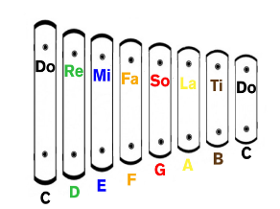

Kisne Banaaya

MOANA Musical Songs
for Summer Production

Maths
Decimals
Negative numbers
Consolidation of all 4 methods


PE

Athletics at Sevenoaks School (Thursday)
Dance (Tuesdays_
PE (Friday)

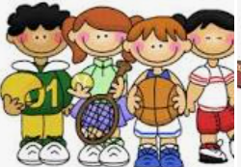

RE
Islam
What does it mean to be a Muslim in Britain today? ( Part 2)


Visit to the Tunbridge Wells Mosque

Enrichment
Mosque
Refugee Immersive
Railway Safety Workshop

Computing

Programming B –
Selection in quizzes 

PSHE

Managing difficult feelings
Managing changes
How my feelings help keeping safe?
Getting help
RSE units
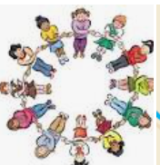

FRENCH


The weather
The body
At the doctor

Design Technology
Mechanical Systems

Pop up Books



