Music
Recorders

English
The iron Man
Writing persuasively
Writing in role

Science
Light
To recognise that we need light in order to see things and that dark is the absence of light. To recognise that shadows are formed when the light from a light source is blocked by a solid object.

Year 3 learning in Term 6


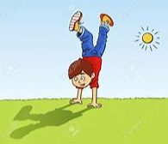


Topic- Geography

Where does our food come from? We will look at the benefits of buying local produce and how food can be traded responsibly.

Art/DT:

DT- Cooking and nutrition
Eating seasonally

To create a recipe that is healthy and nutritious using seasonal foods.

Maths

Revision of arithmetic skills
Shape
Statistics
3, 6, 4 & 8 times table

RE

Sikhism
How do Sikh people worship and celebrate?

PSHE
Growing and Changing
Relationships
Changing bodies and puberty
Keeping safe
Safe and unsafe secrets

French

Consolidating my family
The Body

PE

Athletics and cricket

ICT

Programming – sequencing sound, events and actions in programs

