Science
Habitats - continued
- Identifying and naming a variety of plants and animals in their habitats, including microhabitats.
- To know that most living things are suited to their habitat and where they live provides them with their basic needs.

Geography
What is it like to live by the coast?
- Name and locate the seas and oceans around the UK
- Use compass points.
- Define what the coast is.
- Locate coasts in the UK.
- Identify human features in a coastal town.

English : The Diary of a Killer Cat

To explore, interpret and understand a narrative text.

To develop an understanding of character through their actions and thoughts.

To be able to write from the perspective of different characters in a story.

Term 6
Learning in Year 2

PE

-Athletics
-Hitting and striking
-Skipping

Visitors, trips and Special Events
- Sevenoaks Wildlife Reserve
- Year 2 Assembly
- Forest school


DT Structures: Baby Bear’s Chair
Design, Make and Evaluate a structure that supports a teddy
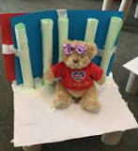


PSHE
Growing and changing
-Ways to give positive feedback to others
-Recognising the range of feelings when we lose something and when there is change.
- Identify different stages of growth as we grow up.

Computing
Robot algorithms and an introduction to quizzes


RE Islam - continued
Who are Muslims and what do they believe?
- What do Muslims think about God?
- Who is the Prophet Muhammed and why is he important to Muslims?
- What is a mosque and what happens there?
- What happens at the celebration of Eid-ul-Fitr, and why?

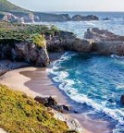
Maths-
- Time – o’clock, half past, quarter past, quarter to.
- Position and Direction
- Statistics
- Problem solving


