English
- Narrative
The Lost Thing by Shaun Tan
- Poetry:
The River by Valerie Bloom
- Grammar
- Spellings from Spelling Shed
- VIPERS Whole Class Reading

Year 4 Owl Class
Term 1 Learning
2026/27

Science

States of Matter

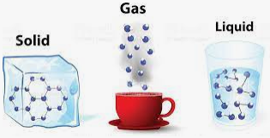

French

Revision
Breakfast
Fruits and vegetables

Music

History/Geography

Geography
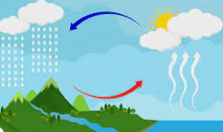
Rivers and the Water Cycle

Visits/Visitors/trips
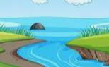

- River Study – Lullingstone Country Park
- Harvest Festival

Maths

- Place value of numbers to 10,000
- Rounding to the nearest 10, 100, 1000
- Addition and subtraction

Music

This little light of mine
Violin lessons

RE
“What do Christians learn from the Creation story?”
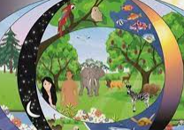

PE
- Hockey
- Netball 

Art/DT 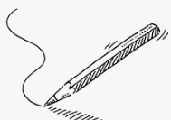

Drawing: Exploring tone, texture and proportion
Drawing using tone to create a 3D effect.
Explore how combining lines and mark making can show texture and tone.
Understanding proportion and creating a collage using colour layering.

PSHE

Zones of Regulation
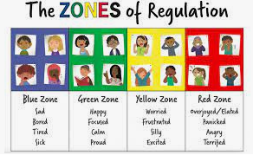

Me and my relationships

althy relationships
Listening to feelings
Bullying
Assertive skills

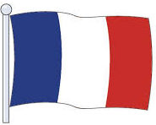
Computing
Computing systems and networks:
The internet

