Music
Violin

Science – Plants – Seed Dispersal
We will be learning:
To identify and describe the functions of different parts of flowering plants: roots, stem or trunk, leaves and flowers.
The part that flowers play in the life cycle of flowering plants, including pollination, seed formation and seed dispersal.

Year 3 learning in Term 1

English
Power of Reading book – Stoneage Boy
Conjunctions, adverbial phrases, fronted adverbials, noun phrases, punctuation prefixes and suffixes possessive apostrophe

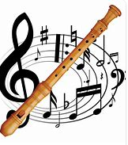

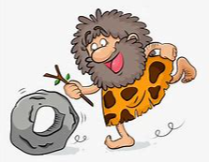
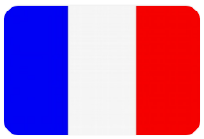
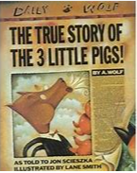
Computing
Creating media - Animation

Art/DT:

Painting and mixed media: Prehistoric painting

Discovering how and why our ancient ancestors made art, experimenting with natural materials to make homemade paints and playing with scale to paint on a range of surfaces.

RE –
What is it like to follow God? We will be learning about the links between the story of Noah and the covenant, as well as the links between the story and the promises made at a wedding ceremony. We will link these ideas to how we live in school and the wider world.

PSHE – Me and My Relationships
Discussing children’s feelings as they make the transition from year 2. We will also be looking at the Zones of Regulation and how they can help us regulate our emotions.

Topic- Stone Age
We will compare the different periods of the Stone Age and how life changed over time.

PE

Basketball
Netball
Tuesdays and Wednesdays

Maths
Place Value
Addition
Subtraction

French
Greetings
Name
Age
Birthday
Alphabet

