English

Narrative outcome: The Princess Blankets by Carol Ann Duffy

Grammar Year 5

Spelling- Spelling Shed

Science

Materials
-Compare and group everyday materials on the basis of their properties
-Understand that some materials will dissolve in liquid to form a solution.

History/Geography
Tudors
What was life like in Tudor England?
-What was King Henry VIII really like and why did he have some many wives?
-What can inventories tell us about Tudor life?

Year 5 FOX CLASS 2026
Term 1 Learning
2024

Music

Enrichment

Trip to Knole House



Music
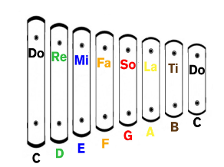

 Religious Education
GOD

What does it mean if God is holy and loving?

Maths
- Understanding place value of numbers to 1,000,000
- Addition
- Subtraction
- Roman numerals

PE
OAA
Hockey and Netball 

PSHE
Zones of regulation
Me and My relationships
Friendship skills, including compromise
Assertive skills
Cooperation
Recognising emotional needs


FRENCH


Greetings
Name
Age
Birthday
Alphabet

Art/DT

Art
Painting and mixed media portraits

Computing
- Computing systems
- Systems and searching


