Curriculum Overview – Year 1

St John’s CE Primary School


Subject | Term 1 | Term 2 | Term 3 | Term 4 | Term 5 | Term 6
English | 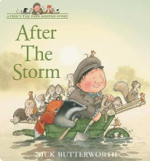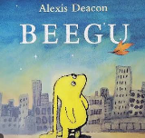 | 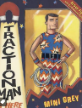    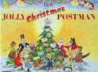 | 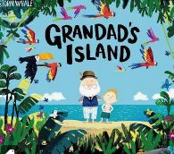 |  | 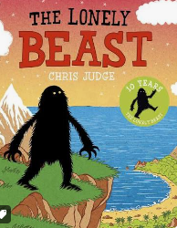 | 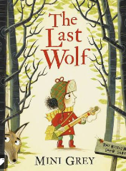
Maths | Place value within 10  Addition and subtraction within 10 | Addition and subtraction with 10  Geometry – 2d and 3d shapes | Place value within 20  Addition and subtraction within 20 | Place value within 50  Length and height  Mass and volume | Multiplication and division  Fractions  Geometry - position | Place value within 100  Measurement – money and time
Science | How does the world around us change through the four seasons? | How does the world around us change through the four seasons? | Humans, senses | How can we identify, group and compare animals, including ourselves? | What are objects made from, and how can we describe and group their materials? | How can we identify and describe the plants and trees growing around us?
Geography |  | What is it like here? |  | What is the weather like in the UK? |  | What is it like to live in Sri Lanka?
History | How am I making history?  The great storm of Sevenoaks |  | How have toys changed? |  | How have explorers changed the world?
Art | Making your mark – drawing |  | Colour splash – painting and mixed media |  | Sculpture and 3D paper play
D.T. |  | Making a moving book - mechanisms |  | Pencil pots – paper craft |  | Smoothies – food technology
Computing | Computing systems and networks – technology around us | Creating media – digital painting | Creating media – digital writing | Data and information – grouping data | Programming A – moving a robot | Programming A – moving a robot
R.E. | What do Christians believe God is like? | INCARNATION Why does Christmas matter to Christians? | GOSPEL What is the good news that Jesus brings? | Why does Easter matter to Christians? | JUDAISM Who is Jewish and what do they believe? (Part 1) | JUDAISM Who is Jewish and what do they believe? (Part 2)
PSHE | Me and my relationships | Valuing differences | Keeping safe | Rights and respects | Being my best | Growing and changing
P.E. | Fundamentals  Forest school | Dance  Sending and receiving | Gymnastics  Ball skills | Fitness  Dance | Invasion games  Athletics | Athletics – net and wall  Striking and fielding

