Curriculum Overview – Year 2

St John’s CE Primary School


Subject | Term 1 | Term 2 | Term 3 | Term 4 | Term 5 | Term 6
English | 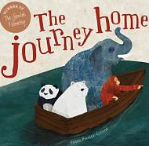 | 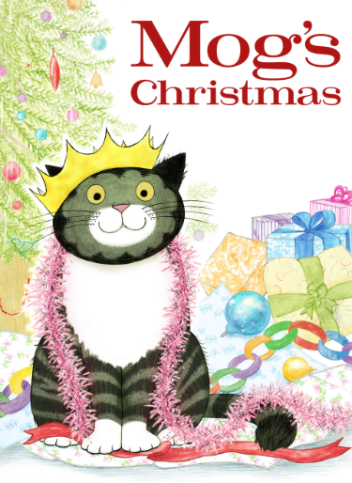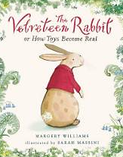 | 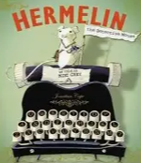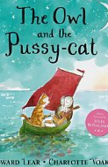 | 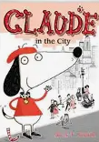 | 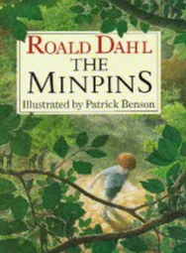 | 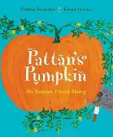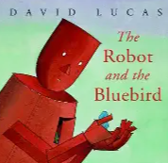
Maths | Place value | Addition and subtraction  Shape | Multiplication and division  Money  Shape – 2d and 3d | Multiplication and division  Measures – length and height, capacity, mass and temperature | Fractions  Time | Time  Position and direction  Statistics  Problem solving
Science | Why are different materials chosen for different jobs, and how can we change their shape? | Why are different materials chosen for different jobs, and how can we change their shape? | What do animals, including humans, need to grow, survive and stay healthy? | What does a plant need to grow from a seed or bulb and stay healthy? | How do we know what is alive, where living things belong and how they depend on each other? | How do we know what is alive, where living things belong and how they depend on each other?
Geography |  | Would you prefer to live in a hot or cold place? |  | Why is our world wonderful? |  | What is it like to live by the coast?
History | How was school different in the past? |  | How did we learn to fly? |  | What is a monarch?
Art | Telling a story – drawing |  | Maps – lino painting, stained glass |  |  | Map it out – craft and design
D.T. |  | Making a moving monster - mechanisms |  | A balanced diet – cooking and nutrition | Baby bear’s chair - sculpture
Computing | Computing systems and networks – IT around us | Creating media – digital photography | Creating media – making music | Data and information – pictograms | Programming A – robot algorithms | Programming A – robot algorithms
R.E. | Creation – Who made the world? | UNIVERSAL How should be care for others and the world and why does it matter? | HUMANISM What is Humanism? | SALVATION Why does Easter matter to Christians? DIGGING DEEPER | ISLAM Who is a Muslim and what do they believe? (Part 1) | ISLAM Who is a Muslim and what do they believe? (Part 2)
PSHE | Me and my relationships | Valuing differences | Keeping safe | Rights and respects | Being my best | Growing and changing
P.E. | Fundamentals  Team building | Yoga  Outdoor games | Sending and receiving  Gymnastics | Fitness  Dance | Forest School  Skipping | Athletics  Hitting and striking

