Curriculum Overview – Year 4

St John’s CE Primary School


Subject | Term 1 | Term 2 | Term 3 | Term 4 | Term 5 | Term 6
English | 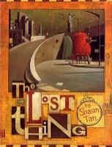 | 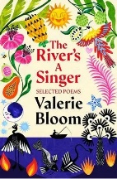  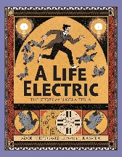 | 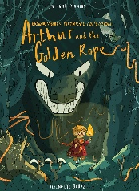 | 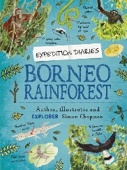 | 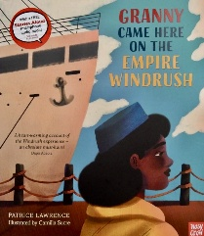 | 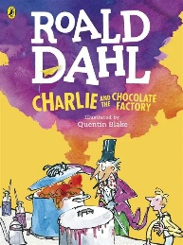
Maths | Place value of numbers to 10,000  Rounding to the nearest 10, 100, 1000  Addition and subtraction | Addition and subtraction  Multiplication and division  Area | Multiplication and division  Length and Perimeter | Division  Fractions  Decimals | Fractions  Decimals  Money | Time  Statistics  Position and Direction
Science | How can materials change state and how does this help explain the water cycle? | What makes an electrical circuit work and how do conductors and insulators affect this? | What can we learn from animals and humans from their teeth, digestive systems and food chains? | How are sounds made and changed and how do they travel to our ears? | How can we classify living things and what happens when their environments change? | How can we classify living things and what happens when their environments change?
Geography | Rivers and the water cycle |  |  | Why are rainforests important to us? | Are all settlements the same?
History |  | What was it like in Anglo Saxon Britain? | What was the impact of the Vikings invading Britain? |  |  | How have children’s lives changed?
Art | Exploring texture, tone and proportion - Drawing |  |  | Fabric of nature – craft and design | Light and dark – painting and mixed media
D.T. |  | Torches – electrical systems | Pneumatic toys |  |  | Adapting a recipe – food technology
Computing | Computing systems and networks – the internet | Creating media – audio production | Creating media – photo editing | Programming A- repetition in shapes | Programming A- repetition in shapes | Programming B – repetition in games
R.E. | CREATION What do Christians learn from the Creation story? | INCARNATION What is the Trinity? | GOSPEL What kind of a world did Jesus want? | SALVATION Why do Christians call the day Jesus died ‘Good Friday’? | HINDU DHARMA What does it mean to be a Hindu in Britain today? (Part 1) | HINDU DHARMA What does it mean to be a Hindu in Britain today? (Part 2)
PSHE | Me and my relationships | Valuing differences | Keeping safe | Rights and respects | Being my best | Growing and changing
P.E. | Hockey  Netball | Tag rugby  Football | Gymnastics  Outdoor activities | Dance  Swimming | Athletics  Forest school | Athletics  Cricket  Forest School
French | Breakfast Fruits and vegetables | Unhealthy food Christmas | Sports I play I do Places I can Musical instruments | Clothes Uniform | School lunch | Setting the table Eating out

