Curriculum Overview – Year 5

St John’s CE Primary School
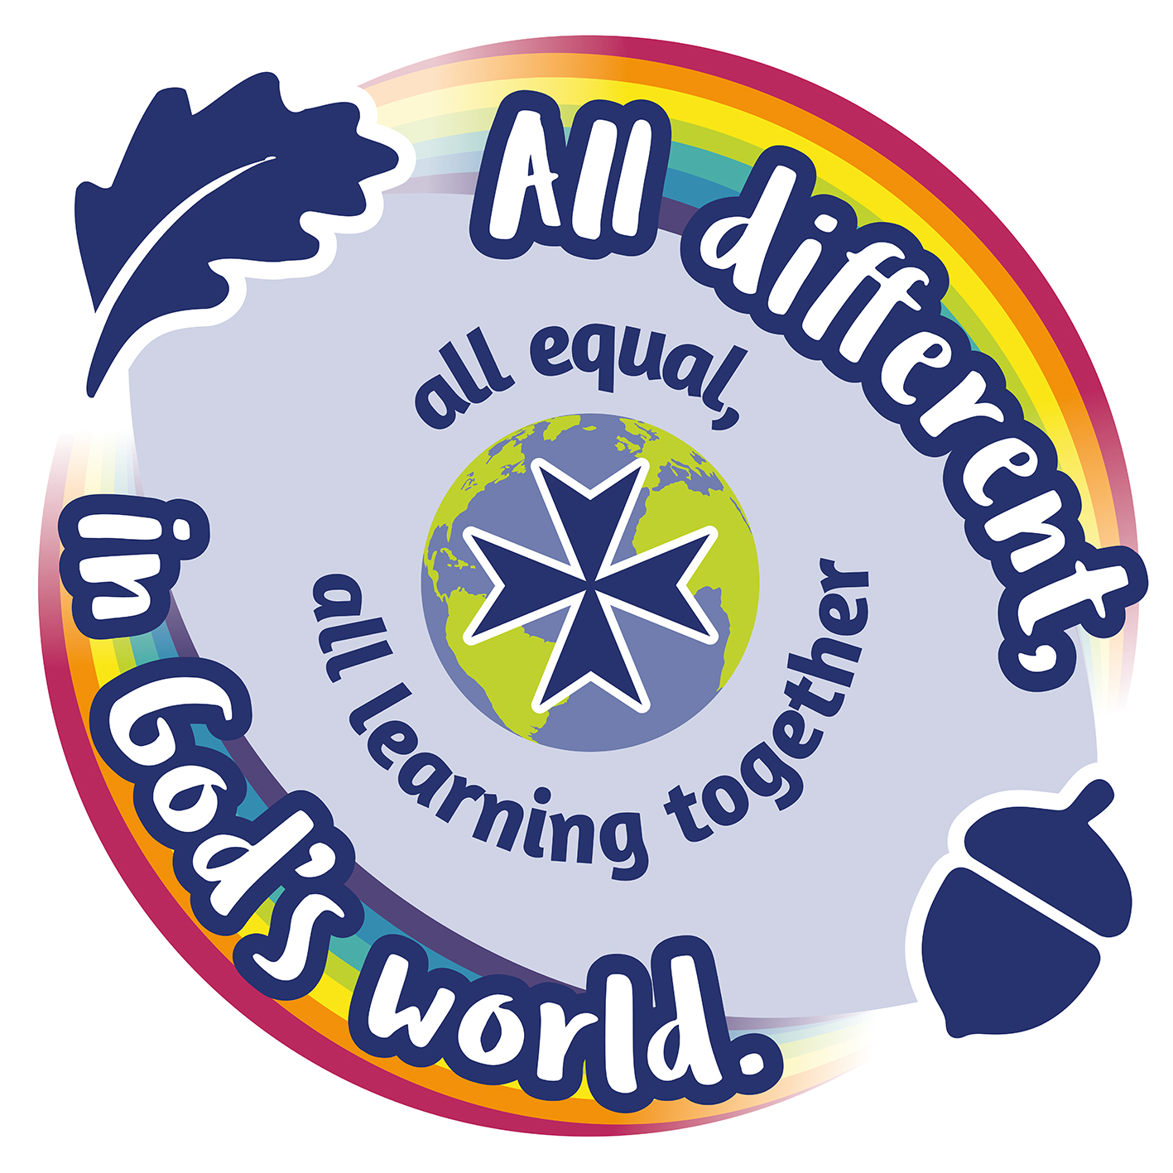

Subject | Term 1 | Term 2 | Term 3 | Term 4 | Term 5 | Term 6
English | 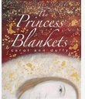 and Tudor Biographies | 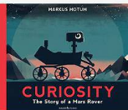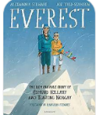 | 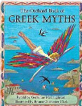  A Shot in the Dark  Poetry: Still I Rise | 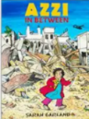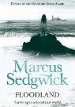 | 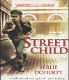 | 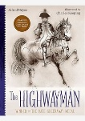
Maths | Understanding place value of numbers to 1,000,000  Addition and subtraction  Roman numerals | Addition and subtraction  Multiples, common multiples  Factors, common factors  Prime, square and cube numbers | Fractions  Multiplication and division | Multiplication and division  Fractions  Decimals and percentages  Angles and coordinates | Decimals and percentages  Measures  Time Consolidation | Decimals  Negative numbers Consolidation of all 4 methods
Science | How do materials behave, and how can their properties and changes help us choose, mix, separate and recover them? | How do the shape and movement of the earth, moon and planets explain what we observe in the sky? | How do materials behave, and how can their properties and changes help us choose, mix, separate and recover them? | How do gravity, resistance and mechanisms affect movement? | How do living things reproduce and how do their life cycles compare? | How do humans change as they grow from birth to old age?
Geography |  | What is it like in a mountain environment? |  | Why do oceans matter? |  | Why does the population change?
History | What was life like in Tudor times? |  | What did the Greeks do for us? |  | What was life like in Victorian times?
Art | Painting and mixed media - Portraits | Making Connections:  Imagining the future |  |  | Craft and design - architecture
D.T. |  |  | Bridges – structures | What could be healthier – food technology |  | Pop-up book – mechanical systems
Computing | Computing systems and networks – systems and searching Programming A – selection in quizzes | Creating media – vector graphs | Creating media – video production | Data and information – flat-file databases | Programming A – selection in quizzes | Programming A – selection in quizzes
R.E. | GOD  What does it mean if God is loving and holy? | INCARNATION  Was Jesus the Messiah? | PEOPLE OF GOD  How can following God bring freedom and justice? | SALVATION  What did Jesus do to save human beings? | ISLAM  What does it mean to be a Muslim in Britain today? (Part 1) | ISLAM  What does it mean to be a Muslim in Britain today? (Part 2)
PSHE | Me and my relationships | Valuing differences | Keeping safe | Rights and respects | Being my best | Growing and changing
P.E. | Outdoor activities  Hockey  Netball | Tag rugby  Football | Gymnastics  Fitness  Forest School | Basketball | Swimming  Athletics | Athletics  Dance
French | Revision  All about me | Where are you from? French speaking countries Europe | Where do you live? House Bedroom | Activities in rooms  Jobs at home  Daily routine | Transport  Being French  Your town  Shops | I like  Free time  Films TV

