Curriculum Overview – Year 6

St John’s CE Primary School


Subject | Term 1 | Term 2 | Term 3 | Term 4 | Term 5 | Term 6
English | 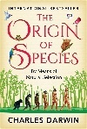 | 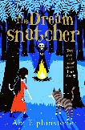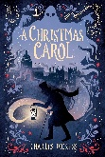 | 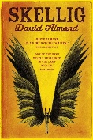 | 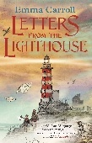 | 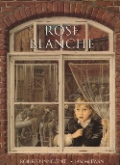 | 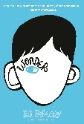
Maths | Place Value  Addition and subtraction, Multiplication and division | Order of Operations  Fractions  Converting Units | Ratio  Algebra  Decimals | Fractions, decimals, percentages  Area, perimeter, volume  Statistics | Geometry  Shape  Algebra | Algebra  Geometry  Problem solving  Investigations
Science | How do fossils, inheritance and adaptation help explain how living things change over time? | How can we change and represent a circuit to control how its components work? | How does light travel to help us see and explain shadows? | How can we classify living things, and how can we justify the groups we put them in? | How does our circulatory system transport what the body needs, and how can our lifestyle affect it? | How do fossils, inheritance and adaptation help explain how living things change over time?
Geography |  | Where does our energy come from? | Deserts |  | Field study
History | Maya Civilisation |  |  | World War II |  | Who should be on a bank note
Art | Make my voice heard |  |  | Photography | Digital world
D.T. |  | Playground design | Biscuits – food technology |  |  | Prop making - sculptures
Computing | Computing systems and networks – communication | Creating media – 3D modelling | Data and information – spreadsheets | Programming A - variables in games | Creating media – web page creation | Creating media – web page creation
R.E. | CREATION Creation and science: conflicting or complementary? | GOSPEL What would Jesus do? | HUMANISM What is Humanism? | JUDAISM What does it mean to be Jewish in Britain today? | UNIVERSAL What can be done to reduce racism? Can religion help? | KINGDOM OF GOD What kind of king is Jesus?
PSHE | Me and my relationships | Valuing differences | Keeping safe | Rights and respects | Being my best | Growing and changing
P.E. | Hockey  Netball  Fitness | Dodgeball  Tag rugby  Football | Gymnastics  Tennis | Yoga  Dodgeball | Rounders  Athletics  Dance | Athletics  Cricket
French | Revision | Christmas French traditions | School Subjects Opinions | Festivals | Revision Future plans Time | Normandy

