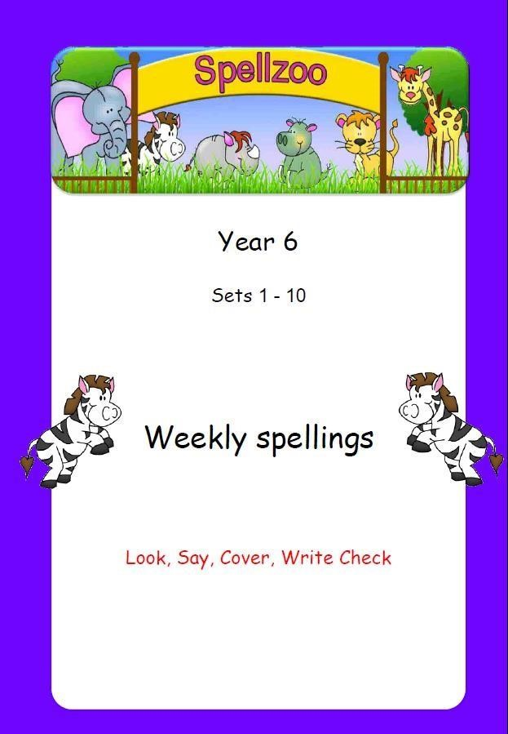
Book 2

Set 1: Words ending in ‘able’
 | 1st try | 2nd try
measurable
irritable
understandable
fashionable
accountable
deliverable
disagreeable
suitable
portable
considerable
neighbour
nuisance
appreciate

Set 2: Words ending in ‘cible’ and ‘gible’
 | 1st try | 2nd try
invincible
forcible
eligible
negligible

legible
illegible
tangible
intangible
unintelligible
submergible
accommodate
opportunity
parliament

Set 3: Words ending in ‘ceable’/‘geable’
 | 1st try | 2nd try
unpronounceable
unnoticeable
irreplaceable
untraceable
rechargeable
interchangeable
unmanageable
exchangeable
forgeable
salvageable
persuade
physical
prejudice

Set 4: Words ending in ‘fer’ with a suffix
 | 1st try | 2nd try
deferred
transferred
transference
referred

reference
referee
preferred
preference
conferred
conference
privilege
profession
programme

Set 5: Words with a hyphen
 | 1st try | 2nd try
re-cover
re-enter
co-operate
co-ordinate
co-own
co-host
re-create
re-elect
co-driver
pre-owned
pronunciation
queue
recognise

Set 6: Words with ‘cei’
 | 1st try | 2nd try
deceive
deceit
receive
receiver
receipt
conceive
conceit
inconceivable
perceive
ceiling
symbol
system
temperature

Set 7: Words with ‘ough’
 | 1st try | 2nd try
tough
rough
enough
thought
brought
nought
cough
thorough
through
though
committee
environment
shoulder

Set 8: Words with silent letters
 | 1st try | 2nd try
thistle
whistle
island
knight
knife
kneel
lamb
comb
climb
doubt
government
communicate
accommodate

Set 9: Homophones 1
 | 1st try | 2nd try
board
bored
serial
cereal
where
wear
mail
male
knight
night
great
grate
key
quay
pane
pain
scent
sent
haul
hall
embarrass
rhyme
rhythm

Set 10: Homophones 2
 | 1st try | 2nd try
pair
pear
knew
new
pail
pale
road
rode
rowed
you
yew
ewe
side
sighed
heard
herd
piece
peace
leek
leak
sacrifice
secretary

