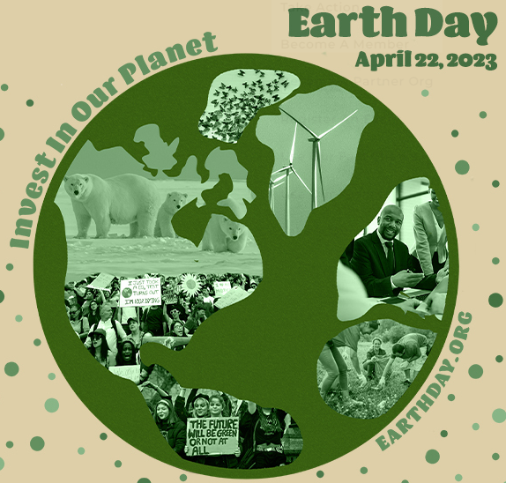

Earth Day
Saturday 22nd April 2023

It’s World Earth Day on Saturday 22nd April 2023. A day to put our planet we live on centre stage. A time to think about how we can help the planet, and how we can take responsibility for helping it to thrive. On this day, we can think about a range of issues with our children, from how we use electricity and water, to recycling waste or planting trees.
What will you do on Earth Day this year?
- Complete an Earth Day homework task (optional) and bring it in to share with your class and teacher.
- Go on a litter pick
- Walk instead of drive
- Plant a tree
- Reuse your rubbish to make it into something new
- Switch off the lights…think about where you use electricity wastefully, switch off those appliances if you’re not using them
- Think about how much water you are using; could you shorten your shower by 1 minute?
- Collect your used batteries and bring them into school to be recycled in our BIG BATTERY HUNT.
- Make a pledge to use less single-use plastic in your packed lunch
- Recycle crisp packets

We hope that through raising awareness and educating the children, they may be inspired to make small changes and help us to protect our amazing planet. I look forward to hearing about how you spent Earth Day and am excited to see any projects you have chosen to complete.

Kind regards,
Mrs Casewell
(Science Lead)

