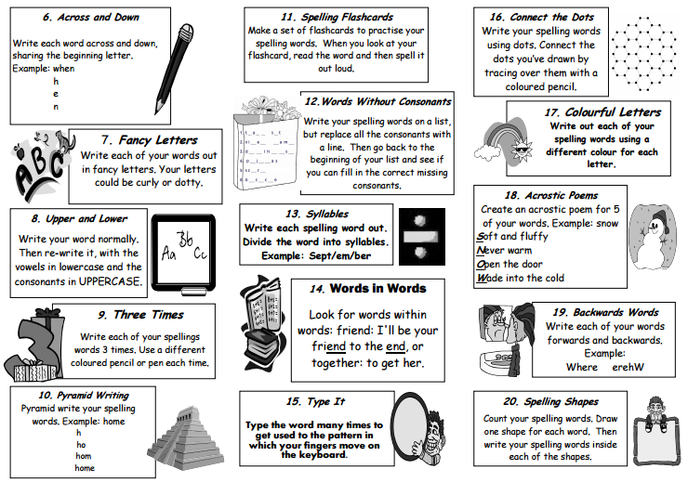

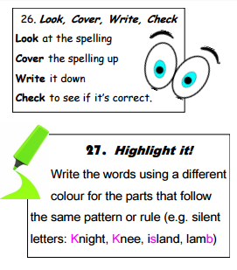
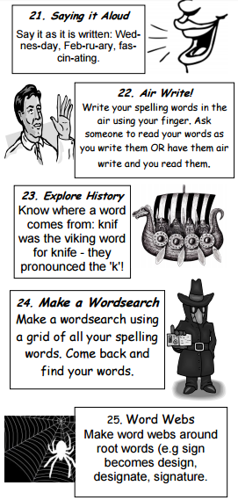
Pa 21. Split the word
e.g. Wed nes day Write each part in a different colour and say say the parts out loud. This is important for words which are are not spoken as they sound.
diff er ent bus i ness

T

Pa Spell Well Activities
U Use the activities to help you learn your sp spelling words.

se

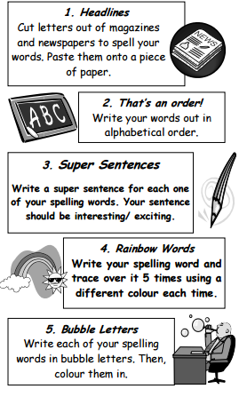

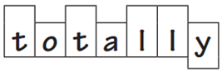
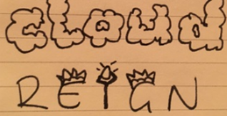
Wed
Pa 29. Draw around the word. Draw around th the word to see tall letters and those with a tail.

Pa 28. Images & Calligrams – Make a
W word memorable by adding pictures.

